Allergy data set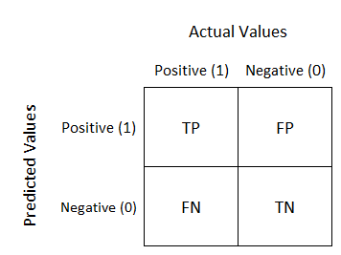

# Pre-processing:

In the first stage, we restricted the information for each type of microbiome given in the data set by only the first five levels to minimize the number of features - from several thousand to several hundred.

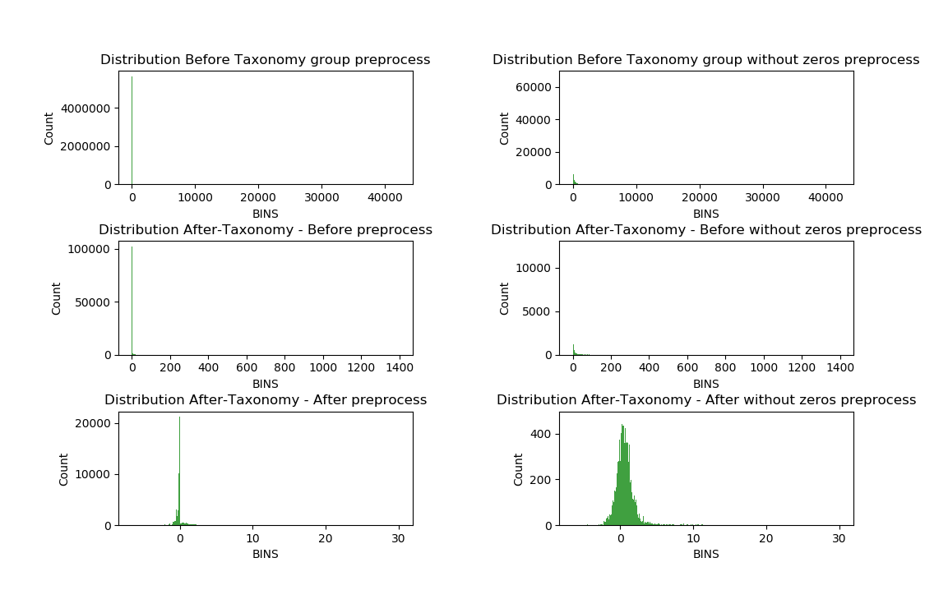In the second stage, we performed normalization using Z score, and log base 10 to obtain normalized values with an average of 0 and standard deviation 1.

In the third stage, we performed PCA to lower the features dimensions to twenty.

We chose a value of 20 according to the accumulation of the eigenvalues variance.

Towards component number 20, we have seen that the cumulative variance does not increase much as we proceed - so we stopped.

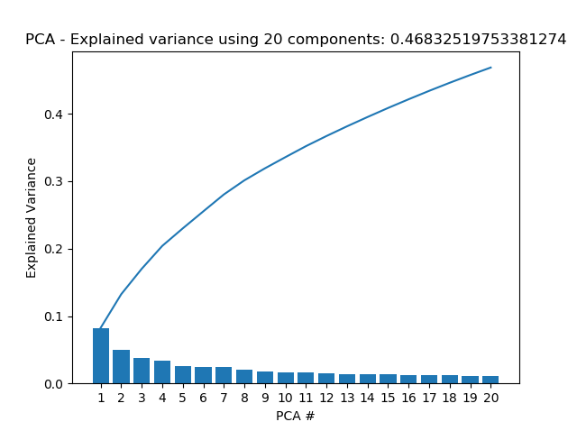

Component 20: 0.0111306300797054, Accumulative variance: 0.4691601802897902

## Distinction between allergic and healthy patients (the control group)

Is patient healthy or allergic?

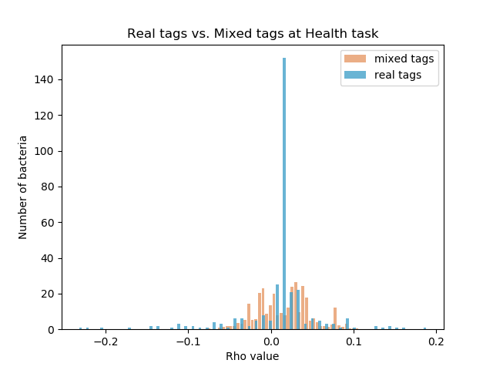

|  |  |
| --- | --- |
| -0.23028 | k__Bacteria; p__Firmicutes; c__Clostridia; o__Clostridiales; f__[Mogibacteriaceae]; g__ |
| -0.21686 | k__Bacteria; p__Actinobacteria; c__Coriobacteriia; o__Coriobacteriales; f__Coriobacteriaceae; g__Adlercreutzia |
| -0.19847 | k__Bacteria; p__Actinobacteria; c__Actinobacteria; o__Actinomycetales; f__Actinomycetaceae; g__Actinomyces |
| -0.1677 | k__Bacteria; p__Actinobacteria; c__Actinobacteria; o__Bifidobacteriales; f__Bifidobacteriaceae; g__Bifidobacterium |
| -0.13957 | k__Bacteria; p__Firmicutes; c__Bacilli; o__Turicibacterales; f__Turicibacteraceae; g__Turicibacter |
| -0.13955 | k__Bacteria; p__Firmicutes; c__Clostridia; o__Clostridiales; f__Peptostreptococcaceae; g__ |
| -0.13193 | k__Bacteria; p__Actinobacteria; c__Coriobacteriia; o__Coriobacteriales; f__Coriobacteriaceae; g__Collinsella |
| -0.13188 | k__Bacteria; p__Actinobacteria; c__Coriobacteriia; o__Coriobacteriales; f__Coriobacteriaceae; g__ |
| -0.11379 | k__Bacteria; p__Firmicutes; c__Clostridia; o__Clostridiales; f__Lachnospiraceae; g__Blautia |
| -0.10584 | k__Bacteria; p__Firmicutes; c__Erysipelotrichi; o__Erysipelotrichales; f__Erysipelotrichaceae; g__ |
| -0.1058 | k__Bacteria; p__Firmicutes; c__Bacilli; o__Lactobacillales; f__Streptococcaceae; g__Streptococcus |
| -0.104 | k__Bacteria; p__Actinobacteria; c__Actinobacteria; o__Actinomycetales; f__Corynebacteriaceae; g__Corynebacterium |
| -0.10203 | k__Bacteria; p__Firmicutes; c__Clostridia; o__Clostridiales; f__Clostridiaceae; g__ |
| -0.09584 | k__Bacteria; p__Firmicutes; c__Clostridia; o__Clostridiales; f__Dehalobacteriaceae; g__Dehalobacterium |
| -0.08952 | k__Bacteria; p__Firmicutes; c__Clostridia; o__Clostridiales; f__Lachnospiraceae; g__Dorea |
| -0.08613 | k__Bacteria; p__Firmicutes; c__Clostridia; o__Clostridiales |
| -0.08232 | k__Bacteria; p__Firmicutes; c__Clostridia; o__Clostridiales; f__; g__ |
| -0.07451 | k__Bacteria; p__Firmicutes; c__Clostridia; o__Clostridiales; f__Lachnospiraceae; g__[Ruminococcus] |
| -0.06773 | k__Bacteria; p__Firmicutes; c__Clostridia; o__Clostridiales; f__Lachnospiraceae; g__Coprococcus |
| -0.06591 | k__Bacteria; p__Firmicutes; c__Clostridia; o__Clostridiales; f__Ruminococcaceae; g__Ruminococcus |
| -0.06586 | k__Bacteria; p__Firmicutes; c__Clostridia; o__Clostridiales; f__Clostridiaceae; g__Clostridium |
| -0.06465 | k__Bacteria; p__Firmicutes |
| -0.05738 | k__Bacteria; p__Firmicutes; c__Clostridia; o__Clostridiales; f__Christensenellaceae; g__Christensenella |
| -0.05486 | k__Bacteria; p__Firmicutes; c__Clostridia; o__Clostridiales; f__Lachnospiraceae; g__ |
| 0.094571 | k__Bacteria; p__Firmicutes; c__Bacilli; o__Lactobacillales; f__Lactobacillaceae; g__Lactobacillus |
| 0.096126 | k__Bacteria; p__Bacteroidetes; c__Bacteroidia; o__Bacteroidales; f__Rikenellaceae; g__ |
| 0.097112 | k__Bacteria; p__Fusobacteria; c__Fusobacteriia; o__Fusobacteriales; f__Fusobacteriaceae; g__Cetobacterium |
| 0.097413 | k__Bacteria; p__Bacteroidetes; c__Bacteroidia; o__Bacteroidales; f__[Odoribacteraceae]; g__Butyricimonas |
| 0.098265 | k__Bacteria; p__Bacteroidetes; c__Bacteroidia; o__Bacteroidales; f__; g__ |
| 0.103697 | k__Bacteria; p__Firmicutes; c__Clostridia; o__Clostridiales; f__Veillonellaceae; g__Megasphaera |
| 0.129471 | k__Bacteria; p__Proteobacteria; c__Deltaproteobacteria; o__Desulfovibrionales; f__Desulfovibrionaceae; g__Bilophila |
| 0.133132 | k__Bacteria; p__Proteobacteria; c__Betaproteobacteria; o__Burkholderiales; f__Alcaligenaceae; g__Sutterella |
| 0.138062 | k__Bacteria; p__Firmicutes; c__Bacilli; o__Lactobacillales; f__Enterococcaceae; g__Enterococcus |
| 0.145918 | k__Bacteria; p__Bacteroidetes; c__Bacteroidia; o__Bacteroidales; f__Bacteroidaceae; g__Bacteroides |
| 0.148944 | k__Bacteria; p__Bacteroidetes; c__Bacteroidia; o__Bacteroidales; f__Rikenellaceae; g__Alistipes |
| 0.153005 | k__Bacteria; p__Firmicutes; c__Clostridia; o__Clostridiales; f__Lachnospiraceae; g__Lachnospira |
| 0.167948 | k__Bacteria; p__Bacteroidetes; c__Bacteroidia; o__Bacteroidales; f__Porphyromonadaceae; g__Parabacteroides |
| 0.194758 | k__Bacteria; p__Bacteroidetes; c__Bacteroidia; o__Bacteroidales; f__Prevotellaceae; g__Prevotella |

Significant bacteria –

Too many to plot.

SVM

The best parameters found by grid search are:

{'C': 0.01, 'gamma': 'scale', 'kernel': 'sigmoid'}

AUC

**train_auc: 0.8126557863501482**

**test_auc: 0.7341666666666667**

**train_rho: 0.3624355900432167**

**test_rho: 0.2615238085198263**

|  |  |  |
| --- | --- | --- |
|  | train accuracy | test accuracy |
| 0 | 0.792818 | 0.747253 |
| 1 | 0.788674 | 0.692308 |
| 2 | 0.796961 | 0.752747 |
| 3 | 0.780387 | 0.697802 |
| 4 | 0.774862 | 0.653846 |
| 5 | 0.801105 | 0.725275 |
| 6 | 0.767956 | 0.675824 |
| 7 | 0.766575 | 0.692308 |
| 8 | 0.783149 | 0.686813 |
| 9 | 0.770718 | 0.791209 |
| average | 0.78232 | 0.711538 |
| AUC | **0.81265** | **0.734166** |

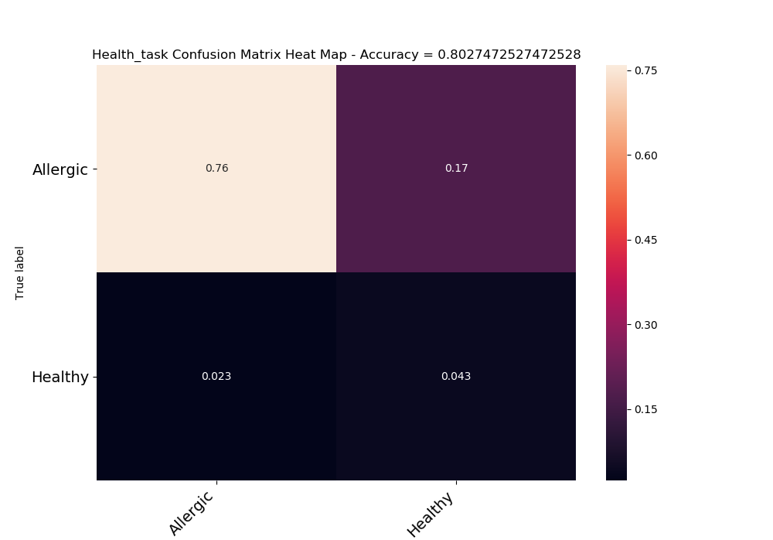

XGBOOST

The best parameters found by grid search are:

{'gamma': 9, 'learning_rate': 0.2, 'max_depth': 3, 'min_child_weight': 7, 'n_estimators': 1000, 'objective': 'binary:logistic'}

Using Anna preprocess-

|  |  |  |
| --- | --- | --- |
|  | train accuracy | test accuracy |
| 0 | 0.776243 | 0.736264 |
| 1 | 0.777624 | 0.769231 |
| 2 | 0.752762 | 0.752747 |
| 3 | 0.766575 | 0.763736 |
| 4 | 0.763812 | 0.714286 |
| average | 0.767403 | 0.747253 |
| AUC | **0.776937** | **0.740784** |

AUC

**train_auc: 0.7769376854599407**

**test_auc: 0.7407843137254903**

**train_rho: 0.3154646247699522**

**test_rho: 0.2651609849632187**

Confusion matrix

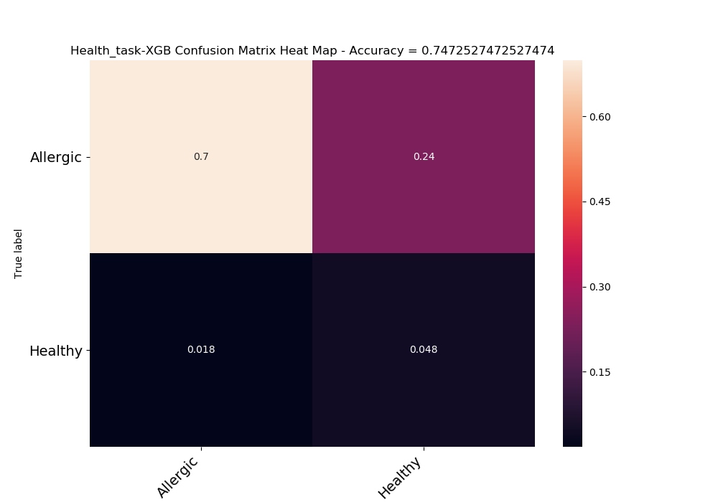

previous AUC

**train_auc: 0.7213560830860534**

**test_auc: 0.6094117647058824**

**train_rho: 0.23536761866139078**

**test_rho: 0.11418995419642765**

|  |  |  |
| --- | --- | --- |
|  | train accuracy | test accuracy |
| average | 0.686326 | 0.660989 |
| AUC | **0.7213560** | **0.6094117** |

|  |  |  |
| --- | --- | --- |
|  | Allergic | Healthy |
| Allergic | 0.624725 | 0.309341 |
| Healthy | 0.02967 | 0.036264 |
| acc | 0.660989 |  |

NN

Using Anna preprocess-

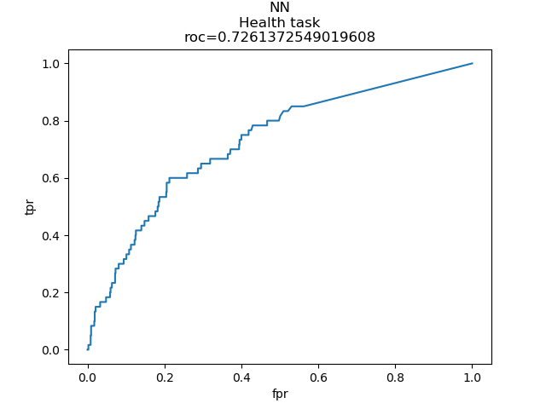

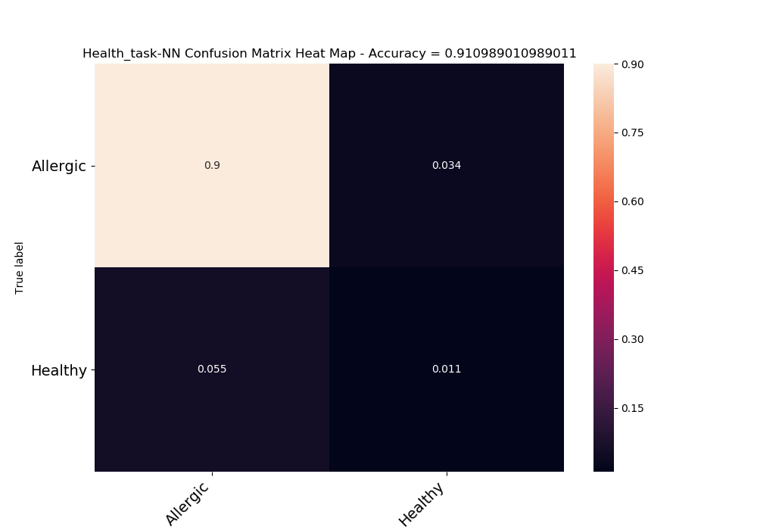

## Response to treatment in real time (i.e. the difference between after response and before response). All allergies.

Is patient in day X of treatment is seem to react to the treatment?

We wanted to check whether there was a difference in microbiome between the patients who responded to the treatment and were labeled A1 and the patients who did not respond to the treatment who were labeled otherwise.

We calculated the Rho values for the bacteria given their real tags and given random tags by mixing those tags but maintaining their distribution.

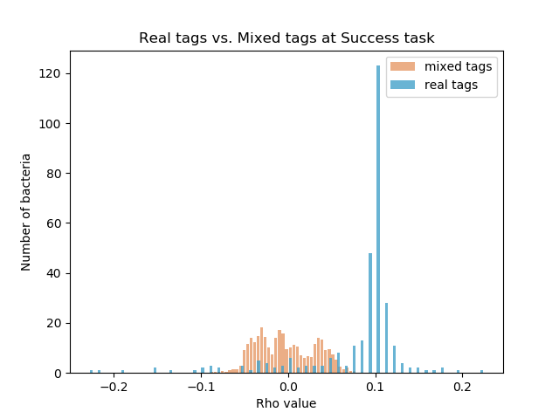

We were pleased to see that the dispersion was wider for the real tags, indicating a link between microbiome and the tags, this is in contrast to the narrower dispersion for mixed labels.

Significant bacteria –

|  |  |
| --- | --- |
| -0.22612 | k__Bacteria; p__Bacteroidetes; c__Bacteroidia; o__Bacteroidales; f__Rikenellaceae; g__ |
| -0.21206 | k__Bacteria; p__Bacteroidetes; c__Bacteroidia; o__Bacteroidales; f__Bacteroidaceae; g__Bacteroides |
| -0.18207 | k__Bacteria; p__Bacteroidetes; c__Bacteroidia; o__Bacteroidales; f__[Barnesiellaceae]; g__ |
| -0.14591 | k__Bacteria; p__Bacteroidetes; c__Bacteroidia; o__Bacteroidales; f__[Odoribacteraceae]; g__Odoribacter |
| -0.14564 | k__Bacteria; p__Bacteroidetes; c__Bacteroidia; o__Bacteroidales; f__Porphyromonadaceae; g__Parabacteroides |
| -0.13353 | k__Bacteria; p__Firmicutes; c__Clostridia; o__Clostridiales; f__Christensenellaceae; g__ |
| -0.10544 | k__Bacteria; p__Firmicutes; c__Clostridia; o__Clostridiales; f__Veillonellaceae; g__Dialister |
| -0.09071 | k__Bacteria; p__Bacteroidetes; c__Bacteroidia; o__Bacteroidales; f__[Odoribacteraceae]; g__Butyricimonas |
| -0.08958 | k__Bacteria; p__Proteobacteria; c__Betaproteobacteria; o__Burkholderiales; f__Oxalobacteraceae; g__Oxalobacter |
| -0.08674 | k__Bacteria; p__Firmicutes; c__Clostridia; o__Clostridiales; f__Lachnospiraceae; g__Lachnobacterium |
| -0.08424 | k__Bacteria; p__Proteobacteria; c__Betaproteobacteria; o__Burkholderiales; f__Alcaligenaceae; g__Sutterella |
| -0.08005 | k__Bacteria; p__Proteobacteria; c__Deltaproteobacteria; o__Desulfovibrionales; f__Desulfovibrionaceae; g__Bilophila |
| -0.07485 | k__Bacteria; p__Firmicutes; c__Clostridia; o__Clostridiales; f__Veillonellaceae; g__Veillonella |
| -0.07322 | k__Bacteria; p__Proteobacteria; c__Gammaproteobacteria; o__Pasteurellales; f__Pasteurellaceae; g__Haemophilus |
| 0.069634 | k__Bacteria; p__Proteobacteria; c__Gammaproteobacteria; o__Pasteurellales; f__Pasteurellaceae; g__Actinobacillus |
| 0.072231 | k__Bacteria; p__Firmicutes; c__Clostridia; o__Clostridiales; f__Dehalobacteriaceae; g__ |
| 0.07228 | k__Bacteria; p__Proteobacteria; c__Gammaproteobacteria; o__Pasteurellales; f__Pasteurellaceae; g__Aggregatibacter |
| 0.076995 | k__Bacteria; p__Firmicutes; c__Clostridia; o__Clostridiales; f__Veillonellaceae; g__Mitsuokella |
| 0.077308 | k__Bacteria; p__Firmicutes; c__Clostridia; o__Clostridiales; f__Lachnospiraceae; g__Shuttleworthia |
| 0.077602 | k__Bacteria; p__Firmicutes; c__Clostridia; o__Clostridiales; f__Lachnospiraceae; g__Clostridium |
| 0.077779 | k__Bacteria; p__Firmicutes; c__Erysipelotrichi; o__Erysipelotrichales; f__Erysipelotrichaceae |
| 0.079082 | k__Bacteria; p__Proteobacteria; c__Deltaproteobacteria; o__Desulfovibrionales; f__Desulfovibrionaceae; g__ |
| 0.079945 | k__Bacteria; p__Bacteroidetes |
| 0.081444 | k__Archaea; p__Euryarchaeota; c__Methanobacteria; o__Methanobacteriales; f__Methanobacteriaceae; g__Methanosphaera |
| 0.082757 | k__Bacteria; p__Firmicutes; c__Erysipelotrichi; o__Erysipelotrichales; f__Erysipelotrichaceae; g__Catenibacterium |
| 0.083551 | k__Bacteria; p__Proteobacteria; c__Epsilonproteobacteria; o__Campylobacterales; f__Campylobacteraceae; g__Campylobacter |
| 0.083679 | k__Bacteria; p__Bacteroidetes; c__Bacteroidia; o__Bacteroidales; f__Prevotellaceae; g__ |
| 0.084129 | k__Bacteria; p__Firmicutes; c__Clostridia; o__Clostridiales; f__EtOH8; g__ |
| 0.085903 | k__Bacteria; p__Firmicutes; c__Clostridia; o__Clostridiales; f__[Mogibacteriaceae]; g__Mogibacterium |
| 0.085903 | k__Bacteria; p__Firmicutes; c__Erysipelotrichi; o__Erysipelotrichales; f__Erysipelotrichaceae; g__RFN20 |
| 0.08605 | k__Bacteria; p__Proteobacteria; c__Gammaproteobacteria; o__Aeromonadales; f__Succinivibrionaceae; g__Succinivibrio |
| 0.086521 | k__Bacteria; p__Actinobacteria; c__Actinobacteria; o__Actinomycetales; f__Corynebacteriaceae; g__Corynebacterium |
| 0.08704 | k__Bacteria; p__Firmicutes; c__Clostridia; o__Clostridiales; f__Ruminococcaceae |
| 0.089735 | k__Bacteria; p__Firmicutes; c__Clostridia; o__Clostridiales; f__Eubacteriaceae; g__Anaerofustis |
| 0.09003 | k__Bacteria; p__Firmicutes; c__Bacilli; o__Lactobacillales; f__Lactobacillaceae; g__Lactobacillus |
| 0.090196 | k__Bacteria; p__Firmicutes; c__Bacilli; o__Lactobacillales; f__Aerococcaceae; g__Abiotrophia |
| 0.090882 | k__Bacteria; p__Firmicutes; c__Clostridia; o__Clostridiales; f__Veillonellaceae; g__Selenomonas |
| 0.091372 | k__Bacteria; p__Actinobacteria; c__Actinobacteria; o__Actinomycetales; f__Actinomycetaceae; g__Varibaculum |
| 0.09393 | k__Bacteria; p__Proteobacteria; c__Alphaproteobacteria; o__Rhizobiales; f__Rhizobiaceae; g__Shinella |
| 0.094058 | k__Bacteria; p__Firmicutes; c__Clostridia; o__Clostridiales; f__[Tissierellaceae]; g__WAL_1855D |
| 0.094214 | k__Bacteria; p__Verrucomicrobia; c__Opitutae; o__HA64; f__; g__ |
| 0.094744 | k__Bacteria; p__Actinobacteria; c__Actinobacteria; o__Actinomycetales; f__Actinomycetaceae; g__Mobiluncus |
| 0.095841 | k__Bacteria; p__Proteobacteria; c__Betaproteobacteria; o__Burkholderiales; f__Comamonadaceae; g__Comamonas |
| 0.09589 | k__Bacteria; p__Firmicutes; c__Clostridia; o__Clostridiales; f__Lachnospiraceae; g__ |
| 0.096018 | k__Bacteria; p__Bacteroidetes; c__Bacteroidia; o__Bacteroidales; f__Porphyromonadaceae; g__Dysgonomonas |
| 0.096351 | k__Bacteria; p__Firmicutes; c__Clostridia; o__Clostridiales; f__Clostridiaceae; g__ |
| 0.096439 | k__Bacteria; p__Tenericutes; c__Mollicutes; o__Anaeroplasmatales; f__Anaeroplasmataceae; g__ |
| 0.096812 | k__Bacteria; p__Proteobacteria; c__Alphaproteobacteria; o__Rhizobiales; f__Methylobacteriaceae; g__ |
| 0.096861 | k__Bacteria; p__Bacteroidetes; c__Bacteroidia; o__Bacteroidales; f__[Paraprevotellaceae]; g__ |
| 0.097253 | k__Bacteria; p__Proteobacteria; c__Betaproteobacteria; o__Burkholderiales; f__Oxalobacteraceae |
| 0.097547 | k__Bacteria; p__Firmicutes; c__Clostridia; o__Clostridiales; f__[Tissierellaceae]; g__ph2 |
| 0.098674 | k__Bacteria; p__Firmicutes; c__Clostridia; o__Clostridiales; f__Veillonellaceae |
| 0.098713 | k__Bacteria; p__Proteobacteria; c__Betaproteobacteria; o__Burkholderiales |
| 0.099203 | k__Bacteria; p__Firmicutes; c__Clostridia; o__Clostridiales; f__Clostridiaceae |
| 0.099487 | k__Bacteria; p__Firmicutes; c__Clostridia; o__Clostridiales; f__Peptostreptococcaceae |
| 0.099899 | k__Bacteria; p__Bacteroidetes; c__Flavobacteriia; o__Flavobacteriales; f__[Weeksellaceae]; g__Wautersiella |
| 0.099928 | k__Bacteria; p__Bacteroidetes; c__Flavobacteriia; o__Flavobacteriales; f__[Weeksellaceae]; g__ |
| 0.100046 | k__Bacteria; p__Firmicutes; c__Clostridia; o__Clostridiales; f__Veillonellaceae; g__ |
| 0.100203 | k__Bacteria; p__Firmicutes |
| 0.100359 | k__Bacteria; p__Proteobacteria; c__Gammaproteobacteria; o__Xanthomonadales; f__Xanthomonadaceae; g__Stenotrophomonas |
| 0.100428 | k__Bacteria; p__Firmicutes; c__Bacilli; o__Bacillales |
| 0.100918 | k__Bacteria; p__Synergistetes; c__Synergistia; o__Synergistales; f__Synergistaceae; g__ |
| 0.101046 | k__Bacteria; p__Proteobacteria; c__Gammaproteobacteria; o__Enterobacteriales; f__Enterobacteriaceae; g__Providencia |
| 0.101222 | k__Bacteria; p__Proteobacteria; c__Betaproteobacteria; o__Burkholderiales; f__Alcaligenaceae; g__Alcaligenes |
| 0.10132 | k__Bacteria; p__Bacteroidetes; c__Bacteroidia; o__Bacteroidales; f__Rikenellaceae; g__Rikenella |
| 0.101643 | k__Bacteria; p__Proteobacteria; c__Gammaproteobacteria; o__Aeromonadales; f__Succinivibrionaceae; g__ |
| 0.101722 | k__Bacteria; p__Firmicutes; c__Clostridia; o__Clostridiales; f__Lachnospiraceae; g__Butyrivibrio |
| 0.101986 | k__Bacteria; p__Firmicutes; c__Bacilli; o__Turicibacterales; f__Turicibacteraceae; g__Turicibacter |
| 0.102016 | k__Bacteria; p__Firmicutes; c__Clostridia; o__Clostridiales; f__Peptostreptococcaceae; g__[Clostridium] |
| 0.102153 | k__Bacteria; p__Firmicutes; c__Clostridia; o__Clostridiales; f__Lachnospiraceae; g__Oribacterium |
| 0.102212 | k__Bacteria; p__Proteobacteria; c__Gammaproteobacteria; o__Enterobacteriales; f__Enterobacteriaceae; g__Shigella |
| 0.102339 | k__Bacteria; p__Firmicutes; c__Clostridia; o__Clostridiales; f__[Tissierellaceae]; g__1-68 |
| 0.10277 | k__Bacteria; p__Proteobacteria; c__Betaproteobacteria; o__Burkholderiales; f__Alcaligenaceae; g__Achromobacter |
| 0.103094 | k__Bacteria; p__Proteobacteria; c__Alphaproteobacteria; o__Rickettsiales; f__Rickettsiaceae; g__Wolbachia |
| 0.103133 | k__Bacteria; p__Firmicutes; c__Bacilli; o__Lactobacillales; f__Carnobacteriaceae; g__Trichococcus |
| 0.103133 | k__Bacteria; p__SR1; c__; o__; f__; g__ |
| 0.103162 | k__Bacteria; p__Firmicutes; c__Bacilli |
| 0.103162 | k__Bacteria; p__Proteobacteria; c__Alphaproteobacteria; o__Rhodobacterales; f__Rhodobacteraceae; g__Amaricoccus |
| 0.103162 | k__Bacteria; p__Proteobacteria; c__Alphaproteobacteria; o__Sphingomonadales; f__Sphingomonadaceae; g__Sphingopyxis |
| 0.103162 | k__Bacteria; p__Proteobacteria; c__Epsilonproteobacteria; o__Campylobacterales; f__Helicobacteraceae; g__Flexispira |
| 0.103162 | k__Bacteria; p__Proteobacteria; c__Gammaproteobacteria; o__Enterobacteriales; f__Enterobacteriaceae; g__Sodalis |
| 0.103162 | k__Bacteria; p__Verrucomicrobia; c__Verrucomicrobiae; o__Verrucomicrobiales; f__Verrucomicrobiaceae; g__Prosthecobacter |
| 0.103221 | k__Bacteria; p__Lentisphaerae; c__[Lentisphaeria]; o__Victivallales; f__Victivallaceae; g__ |
| 0.10326 | k__Bacteria; p__Bacteroidetes; c__Bacteroidia; o__Bacteroidales; f__Porphyromonadaceae; g__Paludibacter |
| 0.10327 | k__Bacteria; p__Proteobacteria; c__Alphaproteobacteria; o__Rhodospirillales; f__Acetobacteraceae; g__Acetobacter |
| 0.103359 | k__Archaea |
| 0.103378 | k__Bacteria; p__Proteobacteria; c__Betaproteobacteria; o__Rhodocyclales; f__Rhodocyclaceae; g__Dok59 |
| 0.103408 | k__Bacteria; p__Firmicutes; c__Clostridia; o__Clostridiales; f__[Mogibacteriaceae]; g__Anaerovorax |
| 0.103427 | k__Bacteria; p__Firmicutes; c__Clostridia; o__Clostridiales; f__Peptococcaceae; g__rc4-4 |
| 0.103496 | k__Bacteria; p__Proteobacteria; c__Alphaproteobacteria; o__Rhodobacterales; f__Rhodobacteraceae |
| 0.103515 | k__Bacteria; p__Bacteroidetes; c__Flavobacteriia; o__Flavobacteriales; f__[Weeksellaceae]; g__Chryseobacterium |
| 0.103515 | k__Bacteria; p__Proteobacteria; c__Alphaproteobacteria; o__Caulobacterales; f__Caulobacteraceae; g__ |
| 0.103515 | k__Bacteria; p__Proteobacteria; c__Alphaproteobacteria; o__Rhizobiales; f__Rhizobiaceae; g__Rhizobium |
| 0.103515 | k__Bacteria; p__Proteobacteria; c__Alphaproteobacteria; o__Rhodospirillales; f__Acetobacteraceae; g__ |
| 0.103515 | k__Bacteria; p__Proteobacteria; c__Alphaproteobacteria; o__Sphingomonadales; f__; g__ |
| 0.103515 | k__Bacteria; p__Proteobacteria; c__Alphaproteobacteria; o__Sphingomonadales; f__Sphingomonadaceae; g__Sphingobium |
| 0.103535 | k__Bacteria; p__Chloroflexi; c__Anaerolineae; o__GCA004; f__; g__ |
| 0.103623 | k__Bacteria; p__Firmicutes; c__Bacilli; o__Bacillales; f__Bacillaceae; g__Bacillus |
| 0.103662 | k__Bacteria; p__Proteobacteria; c__Alphaproteobacteria; o__Caulobacterales; f__Caulobacteraceae |
| 0.103966 | k__Bacteria; p__Firmicutes; c__Clostridia; o__Clostridiales; f__Lachnospiraceae; g__Pseudobutyrivibrio |
| 0.104005 | k__Bacteria; p__Spirochaetes; c__Spirochaetes; o__Spirochaetales; f__Spirochaetaceae; g__Treponema |
| 0.104054 | k__Bacteria; p__Firmicutes; c__Clostridia; o__Clostridiales; f__Clostridiaceae; g__02d06 |
| 0.104074 | k__Bacteria; p__Bacteroidetes; c__Cytophagia; o__Cytophagales; f__Cytophagaceae; g__Leadbetterella |
| 0.104074 | k__Bacteria; p__Firmicutes; c__Bacilli; o__Gemellales; f__Gemellaceae; g__ |
| 0.104074 | k__Bacteria; p__Firmicutes; c__Bacilli; o__Lactobacillales; f__Aerococcaceae; g__Facklamia |
| 0.104113 | k__Bacteria; p__Firmicutes; c__Bacilli; o__Lactobacillales |
| 0.104201 | k__Bacteria; p__Bacteroidetes; c__Sphingobacteriia; o__Sphingobacteriales; f__Sphingobacteriaceae; g__Sphingobacterium |
| 0.10427 | k__Bacteria; p__Verrucomicrobia; c__Opitutae; o__[Cerasicoccales]; f__[Cerasicoccaceae]; g__ |
| 0.104309 | k__Bacteria; p__Firmicutes; c__Clostridia; o__Clostridiales; f__[Tissierellaceae]; g__Gallicola |
| 0.104368 | k__Bacteria; p__Actinobacteria; c__Actinobacteria; o__Actinomycetales; f__Actinomycetaceae; g__Actinomyces |
| 0.104437 | k__Bacteria; p__Proteobacteria; c__Betaproteobacteria; o__Neisseriales; f__Neisseriaceae; g__Kingella |
| 0.104456 | k__Bacteria; p__Proteobacteria; c__Gammaproteobacteria; o__Xanthomonadales; f__Xanthomonadaceae; g__Pseudoxanthomonas |
| 0.104486 | k__Bacteria; p__Firmicutes; c__Clostridia; o__Clostridiales; f__Ruminococcaceae; g__Butyricicoccus |
| 0.104495 | k__Bacteria; p__Firmicutes; c__Bacilli; o__Lactobacillales; f__Leuconostocaceae; g__Weissella |
| 0.104505 | k__Bacteria; p__Firmicutes; c__Clostridia; o__Clostridiales; f__Ruminococcaceae; g__Sporobacter |
| 0.104642 | k__Bacteria; p__Actinobacteria; c__Actinobacteria; o__Actinomycetales; f__Microbacteriaceae; g__Leucobacter |
| 0.104731 | k__Bacteria; p__Proteobacteria; c__Alphaproteobacteria; o__Rhizobiales; f__Brucellaceae; g__Ochrobactrum |
| 0.104731 | k__Bacteria; p__Proteobacteria; c__Betaproteobacteria; o__Burkholderiales; f__Comamonadaceae; g__Delftia |
| 0.10476 | k__Bacteria; p__Firmicutes; c__Clostridia; o__Clostridiales; f__Ruminococcaceae; g__Gemmiger |
| 0.10476 | k__Bacteria; p__Proteobacteria; c__Alphaproteobacteria; o__Rhizobiales; f__Rhizobiaceae; g__Agrobacterium |
| 0.104809 | k__Bacteria; p__[Thermi]; c__Deinococci; o__Thermales; f__Thermaceae; g__Thermus |
| 0.104838 | k__Bacteria; p__Bacteroidetes; c__Flavobacteriia; o__Flavobacteriales; f__Flavobacteriaceae; g__Capnocytophaga |
| 0.104838 | k__Bacteria; p__Synergistetes; c__Synergistia; o__Synergistales; f__Synergistaceae; g__Synergistes |
| 0.105034 | k__Bacteria; p__Actinobacteria; c__Coriobacteriia; o__Coriobacteriales; f__Coriobacteriaceae; g__Eggerthella |
| 0.105054 | k__Bacteria; p__Fusobacteria; c__Fusobacteriia; o__Fusobacteriales; f__Leptotrichiaceae; g__ |
| 0.105074 | k__Bacteria; p__Firmicutes; c__Bacilli; o__Bacillales; f__Staphylococcaceae; g__Jeotgalicoccus |
| 0.105113 | k__Bacteria; p__Proteobacteria; c__Betaproteobacteria; o__Neisseriales; f__Neisseriaceae; g__Eikenella |
| 0.105132 | k__Bacteria; p__Fusobacteria; c__Fusobacteriia; o__Fusobacteriales; f__Leptotrichiaceae; g__Leptotrichia |
| 0.105162 | k__Bacteria; p__Firmicutes; c__Bacilli; o__Bacillales; f__Bacillaceae |
| 0.105191 | k__Bacteria; p__Proteobacteria; c__Gammaproteobacteria; o__Enterobacteriales; f__Enterobacteriaceae; g__Enterobacter |
| 0.105221 | k__Bacteria; p__Bacteroidetes; c__Bacteroidia; o__Bacteroidales; f__S24-7; g__ |
| 0.10527 | k__Bacteria; p__Proteobacteria; c__Alphaproteobacteria; o__Rhizobiales; f__Hyphomicrobiaceae; g__ |
| 0.105397 | k__Bacteria; p__Bacteroidetes; c__Bacteroidia; o__Bacteroidales |
| 0.105485 | k__Bacteria; p__Proteobacteria; c__Betaproteobacteria; o__Burkholderiales; f__Burkholderiaceae; g__Lautropia |
| 0.105515 | k__Bacteria; p__Proteobacteria; c__Betaproteobacteria; o__Neisseriales; f__Neisseriaceae; g__ |
| 0.105573 | k__Bacteria; p__Proteobacteria |
| 0.105642 | k__Bacteria; p__Bacteroidetes; c__Bacteroidia; o__Bacteroidales; f__Rikenellaceae |
| 0.105789 | k__Bacteria; p__Proteobacteria; c__Gammaproteobacteria; o__Pseudomonadales; f__Moraxellaceae; g__Enhydrobacter |
| 0.105907 | k__Bacteria; p__Firmicutes; c__Clostridia; o__Clostridiales; f__Lachnospiraceae; g__Catonella |
| 0.106044 | k__Bacteria; p__Proteobacteria; c__Gammaproteobacteria; o__Pasteurellales; f__Pasteurellaceae |
| 0.106289 | k__Bacteria; p__Firmicutes; c__Clostridia; o__Clostridiales; f__[Tissierellaceae]; g__Anaerococcus |
| 0.106309 | k__Bacteria; p__Tenericutes; c__Mollicutes; o__Mycoplasmatales; f__Mycoplasmataceae; g__Mycoplasma |
| 0.106387 | k__Bacteria; p__Proteobacteria; c__Gammaproteobacteria; o__Pseudomonadales; f__Pseudomonadaceae |
| 0.106416 | k__Bacteria; p__Firmicutes; c__Clostridia; o__Clostridiales; f__Christensenellaceae |
| 0.106495 | k__Bacteria; p__Firmicutes; c__Clostridia; o__Clostridiales; f__Ruminococcaceae; g__Ethanoligenens |
| 0.106603 | k__Bacteria; p__Actinobacteria |
| 0.10672 | k__Bacteria; p__Actinobacteria; c__Actinobacteria; o__Actinomycetales; f__Dermabacteraceae; g__Dermabacter |
| 0.10672 | k__Bacteria; p__Actinobacteria; c__Actinobacteria; o__Actinomycetales; f__Micrococcaceae |
| 0.10672 | k__Bacteria; p__Bacteroidetes; c__Bacteroidia; o__Bacteroidales; f__[Paraprevotellaceae]; g__CF231 |
| 0.10672 | k__Bacteria; p__Firmicutes; c__Bacilli; o__Bacillales; f__Bacillaceae; g__Geobacillus |
| 0.10672 | k__Bacteria; p__Firmicutes; c__Clostridia; o__Clostridiales; f__[Acidaminobacteraceae]; g__ |
| 0.10672 | k__Bacteria; p__Fusobacteria; c__Fusobacteriia; o__Fusobacteriales; f__Leptotrichiaceae; g__Sneathia |
| 0.10672 | k__Bacteria; p__Proteobacteria; c__Alphaproteobacteria; o__Rhizobiales; f__Bradyrhizobiaceae; g__Balneimonas |
| 0.10672 | k__Bacteria; p__Proteobacteria; c__Gammaproteobacteria; o__Aeromonadales; f__Succinivibrionaceae |
| 0.106818 | k__Bacteria; p__Bacteroidetes; c__[Saprospirae]; o__[Saprospirales]; f__Chitinophagaceae; g__ |
| 0.107004 | k__Bacteria; p__Firmicutes; c__Clostridia; o__Clostridiales; f__[Tissierellaceae]; g__ |
| 0.107083 | k__Bacteria; p__Bacteroidetes; c__Bacteroidia; o__Bacteroidales; f__Porphyromonadaceae |
| 0.107093 | k__Bacteria; p__Bacteroidetes; c__Bacteroidia; o__Bacteroidales; f__[Paraprevotellaceae]; g__YRC22 |
| 0.107269 | k__Bacteria; p__Proteobacteria; c__Gammaproteobacteria; o__Enterobacteriales; f__Enterobacteriaceae; g__Plesiomonas |
| 0.107347 | k__Bacteria; p__Cyanobacteria; c__ML635J-21; o__; f__; g__ |
| 0.107357 | k__Bacteria; p__Proteobacteria; c__Deltaproteobacteria; o__Bdellovibrionales; f__Bdellovibrionaceae; g__Bdellovibrio |
| 0.107367 | k__Bacteria; p__Proteobacteria; c__Gammaproteobacteria; o__Enterobacteriales; f__Enterobacteriaceae; g__Proteus |
| 0.107475 | k__Bacteria; p__Firmicutes; c__Clostridia; o__Clostridiales; f__Clostridiaceae; g__SMB53 |
| 0.107641 | k__Bacteria; p__Actinobacteria; c__Actinobacteria; o__Actinomycetales; f__Intrasporangiaceae |
| 0.107651 | k__Bacteria; p__Proteobacteria; c__Betaproteobacteria; o__Burkholderiales; f__Burkholderiaceae; g__Burkholderia |
| 0.107661 | k__Bacteria; p__Acidobacteria; c__Acidobacteria-6; o__iii1-15; f__mb2424; g__ |
| 0.107681 | k__Bacteria; p__Proteobacteria; c__Alphaproteobacteria; o__Sphingomonadales; f__Sphingomonadaceae; g__ |
| 0.10773 | k__Bacteria; p__Proteobacteria; c__Gammaproteobacteria; o__Enterobacteriales; f__Enterobacteriaceae; g__Erwinia |
| 0.107779 | k__Bacteria; p__Firmicutes; c__Bacilli; o__Bacillales; f__Paenibacillaceae; g__Paenibacillus |
| 0.107779 | k__Bacteria; p__TM7; c__TM7-3; o__CW040; f__F16; g__ |
| 0.107877 | k__Bacteria; p__Firmicutes; c__Bacilli; o__Lactobacillales; f__Lactobacillaceae |
| 0.108053 | k__Bacteria; p__Bacteroidetes; c__Flavobacteriia; o__Flavobacteriales; f__Flavobacteriaceae; g__Flavobacterium |
| 0.108053 | k__Bacteria; p__Proteobacteria; c__Alphaproteobacteria; o__Sphingomonadales; f__Sphingomonadaceae; g__Novosphingobium |
| 0.108063 | k__Bacteria; p__Proteobacteria; c__Alphaproteobacteria; o__BD7-3; f__; g__ |
| 0.108416 | k__Bacteria; p__Bacteroidetes; c__Bacteroidia; o__Bacteroidales; f__Prevotellaceae |
| 0.108416 | k__Bacteria; p__[Thermi]; c__Deinococci; o__Deinococcales; f__Deinococcaceae; g__R18-435 |
| 0.109014 | k__Bacteria; p__Proteobacteria; c__Alphaproteobacteria; o__Rhodospirillales; f__Acetobacteraceae; g__Gluconobacter |
| 0.10919 | k__Bacteria; p__Proteobacteria; c__Gammaproteobacteria; o__Enterobacteriales; f__Enterobacteriaceae; g__Serratia |
| 0.109357 | k__Bacteria; p__Proteobacteria; c__Alphaproteobacteria; o__Rhizobiales; f__Hyphomicrobiaceae; g__Devosia |
| 0.109366 | k__Bacteria; p__Fusobacteria; c__Fusobacteriia; o__Fusobacteriales; f__Fusobacteriaceae; g__Cetobacterium |
| 0.109406 | k__Bacteria; p__Actinobacteria; c__Actinobacteria; o__Actinomycetales; f__Pseudonocardiaceae |
| 0.109464 | k__Bacteria; p__Proteobacteria; c__Betaproteobacteria; o__Burkholderiales; f__Oxalobacteraceae; g__Janthinobacterium |
| 0.109474 | k__Bacteria; p__Actinobacteria; c__Actinobacteria; o__Actinomycetales; f__Nocardiaceae; g__Rhodococcus |
| 0.1097 | k__Bacteria; p__Proteobacteria; c__Alphaproteobacteria; o__Rhizobiales; f__Rhizobiaceae; g__ |
| 0.1097 | k__Bacteria; p__Proteobacteria; c__Betaproteobacteria; o__Burkholderiales; f__Oxalobacteraceae; g__Cupriavidus |
| 0.109749 | k__Bacteria; p__Cyanobacteria; c__Oscillatoriophycideae; o__Oscillatoriales; f__Phormidiaceae; g__Phormidium |
| 0.110111 | k__Bacteria; p__Proteobacteria; c__Betaproteobacteria; o__Burkholderiales; f__Burkholderiaceae |
| 0.11018 | k__Bacteria; p__Proteobacteria; c__Alphaproteobacteria; o__Rhizobiales; f__; g__ |
| 0.110248 | k__Bacteria; p__Actinobacteria; c__Actinobacteria; o__Bifidobacteriales; f__Bifidobacteriaceae |
| 0.110248 | k__Bacteria; p__Proteobacteria; c__Alphaproteobacteria; o__Rhodobacterales; f__Rhodobacteraceae; g__Paracoccus |
| 0.110248 | k__Bacteria; p__Proteobacteria; c__Betaproteobacteria; o__Burkholderiales; f__Alcaligenaceae; g__ |
| 0.110513 | k__Bacteria; p__Chloroflexi; c__Thermomicrobia; o__AKYG1722; f__; g__ |
| 0.110513 | k__Bacteria; p__Firmicutes; c__Erysipelotrichi; o__Erysipelotrichales; f__Erysipelotrichaceae; g__Clostridium |
| 0.110582 | k__Bacteria; p__Proteobacteria; c__Alphaproteobacteria; o__Rhizobiales; f__Brucellaceae |
| 0.11066 | k__Bacteria; p__Proteobacteria; c__Gammaproteobacteria; o__Enterobacteriales; f__Enterobacteriaceae |
| 0.110807 | k__Bacteria; p__Chloroflexi; c__Anaerolineae; o__SBR1031; f__A4b; g__ |
| 0.110807 | k__Bacteria; p__Proteobacteria; c__Alphaproteobacteria; o__Rhizobiales; f__Phyllobacteriaceae; g__ |
| 0.110807 | k__Bacteria; p__Proteobacteria; c__Betaproteobacteria; o__Burkholderiales; f__Comamonadaceae; g__Methylibium |
| 0.110807 | k__Bacteria; p__Proteobacteria; c__Deltaproteobacteria; o__Myxococcales; f__; g__ |
| 0.110895 | k__Bacteria; p__Proteobacteria; c__Alphaproteobacteria; o__Rhizobiales |
| 0.110895 | k__Bacteria; p__WPS-2; c__; o__; f__; g__ |
| 0.111013 | k__Bacteria; p__Firmicutes; c__Clostridia; o__Clostridiales; f__Ruminococcaceae; g__Clostridium |
| 0.111209 | k__Bacteria; p__Actinobacteria; c__Thermoleophilia; o__Solirubrobacterales; f__Conexibacteraceae; g__ |
| 0.111219 | k__Bacteria; p__Proteobacteria; c__Alphaproteobacteria; o__Caulobacterales; f__Caulobacteraceae; g__Mycoplana |
| 0.111268 | k__Bacteria; p__Bacteroidetes; c__Sphingobacteriia; o__Sphingobacteriales; f__Sphingobacteriaceae; g__Pedobacter |
| 0.111268 | k__Bacteria; p__Proteobacteria; c__Alphaproteobacteria; o__Sphingomonadales; f__Sphingomonadaceae |
| 0.111356 | k__Bacteria; p__Actinobacteria; c__Actinobacteria; o__Actinomycetales; f__Microbacteriaceae |
| 0.111356 | k__Bacteria; p__Lentisphaerae; c__[Lentisphaeria]; o__Victivallales; f__Victivallaceae; g__Victivallis |
| 0.111503 | k__Bacteria; p__TM7; c__TM7-3; o__; f__; g__ |
| 0.111758 | k__Bacteria; p__Firmicutes; c__Bacilli; o__Bacillales; f__Staphylococcaceae; g__Staphylococcus |
| 0.112052 | k__Bacteria; p__Proteobacteria; c__Betaproteobacteria; o__Burkholderiales; f__Comamonadaceae |
| 0.112316 | k__Bacteria; p__Proteobacteria; c__Epsilonproteobacteria; o__Campylobacterales; f__Helicobacteraceae |
| 0.11263 | k__Bacteria; p__Firmicutes; c__Clostridia; o__Clostridiales; f__Peptococcaceae; g__Peptococcus |
| 0.112659 | k__Bacteria; p__Bacteroidetes; c__[Saprospirae]; o__[Saprospirales]; f__Chitinophagaceae; g__Sediminibacterium |
| 0.113022 | k__Bacteria; p__Proteobacteria; c__Epsilonproteobacteria; o__Campylobacterales; f__Helicobacteraceae; g__Helicobacter |
| 0.113257 | k__Bacteria; p__Proteobacteria; c__Gammaproteobacteria; o__Enterobacteriales; f__Enterobacteriaceae; g__Citrobacter |
| 0.113287 | k__Bacteria; p__Firmicutes; c__Clostridia; o__Clostridiales; f__Veillonellaceae; g__Schwartzia |
| 0.113345 | k__Bacteria; p__Firmicutes; c__Bacilli; o__Gemellales; f__Gemellaceae; g__Gemella |
| 0.113434 | k__Bacteria; p__Bacteroidetes; c__Bacteroidia; o__Bacteroidales; f__Rikenellaceae; g__AF12 |
| 0.113443 | k__Bacteria; p__Proteobacteria; c__Gammaproteobacteria; o__Enterobacteriales; f__Enterobacteriaceae; g__Trabulsiella |
| 0.113483 | k__Bacteria; p__Firmicutes; c__Erysipelotrichi; o__Erysipelotrichales; f__Erysipelotrichaceae; g__Coprobacillus |
| 0.113884 | k__Bacteria; p__Firmicutes; c__Clostridia; o__Clostridiales; f__Lachnospiraceae; g__Epulopiscium |
| 0.11412 | k__Bacteria; p__Actinobacteria; c__Coriobacteriia; o__Coriobacteriales; f__Coriobacteriaceae |
| 0.114159 | k__Bacteria; p__Proteobacteria; c__Betaproteobacteria; o__Neisseriales; f__Neisseriaceae |
| 0.114286 | k__Bacteria; p__Proteobacteria; c__Gammaproteobacteria; o__Pseudomonadales; f__Moraxellaceae; g__Acinetobacter |
| 0.114453 | k__Bacteria; p__Proteobacteria; c__Betaproteobacteria; o__Rhodocyclales; f__Rhodocyclaceae; g__Thauera |
| 0.114727 | k__Bacteria; p__Firmicutes; c__Clostridia; o__Clostridiales; f__[Tissierellaceae]; g__Peptoniphilus |
| 0.114767 | k__Bacteria; p__Proteobacteria; c__Gammaproteobacteria; o__Enterobacteriales; f__Enterobacteriaceae; g__Yersinia |
| 0.115247 | k__Bacteria; p__Actinobacteria; c__Actinobacteria; o__Bifidobacteriales; f__Bifidobacteriaceae; g__Alloscardovia |
| 0.115443 | k__Bacteria; p__Proteobacteria; c__Alphaproteobacteria; o__Caulobacterales; f__Caulobacteraceae; g__Brevundimonas |
| 0.115443 | k__Bacteria; p__Proteobacteria; c__Alphaproteobacteria; o__Rhodobacterales; f__Rhodobacteraceae; g__Rhodobacter |
| 0.115943 | k__Bacteria; p__Proteobacteria; c__Gammaproteobacteria; o__Cardiobacteriales; f__Cardiobacteriaceae; g__Cardiobacterium |
| 0.115992 | k__Bacteria; p__Firmicutes; c__Erysipelotrichi; o__Erysipelotrichales; f__Erysipelotrichaceae; g__Allobaculum |
| 0.116256 | k__Bacteria; p__Firmicutes; c__Bacilli; o__Lactobacillales; f__Aerococcaceae; g__Alloiococcus |
| 0.117913 | k__Bacteria; p__Bacteroidetes; c__Bacteroidia; o__Bacteroidales; f__; g__ |
| 0.118471 | k__Bacteria; p__Firmicutes; c__Clostridia; o__Clostridiales; f__[Tissierellaceae]; g__Finegoldia |
| 0.11855 | k__Bacteria; p__Firmicutes; c__Clostridia; o__Clostridiales; f__Lachnospiraceae; g__Moryella |
| 0.119794 | k__Bacteria; p__Actinobacteria; c__Actinobacteria; o__Bifidobacteriales; f__Bifidobacteriaceae; g__Bifidobacterium |
| 0.119922 | k__Bacteria; p__Firmicutes; c__Bacilli; o__Lactobacillales; f__Leuconostocaceae; g__ |
| 0.12097 | k__Bacteria; p__Firmicutes; c__Clostridia; o__Clostridiales; f__[Tissierellaceae]; g__Parvimonas |
| 0.122156 | k__Bacteria; p__Deferribacteres; c__Deferribacteres; o__Deferribacterales; f__Deferribacteraceae; g__Mucispirillum |
| 0.123264 | k__Bacteria; p__Tenericutes; c__Mollicutes; o__Anaeroplasmatales; f__Anaeroplasmataceae; g__Anaeroplasma |
| 0.123538 | k__Bacteria; p__Actinobacteria; c__Coriobacteriia; o__Coriobacteriales; f__Coriobacteriaceae; g__Collinsella |
| 0.124156 | k__Bacteria; p__Firmicutes; c__Bacilli; o__Lactobacillales; f__Streptococcaceae; g__Streptococcus |
| 0.124979 | k__Bacteria; p__Actinobacteria; c__Coriobacteriia; o__Coriobacteriales; f__Coriobacteriaceae; g__Atopobium |
| 0.126341 | k__Bacteria; p__Synergistetes; c__Synergistia; o__Synergistales; f__Dethiosulfovibrionaceae; g__TG5 |
| 0.126508 | k__Bacteria; p__Proteobacteria; c__Gammaproteobacteria; o__Pseudomonadales; f__Pseudomonadaceae; g__Pseudomonas |
| 0.127115 | k__Bacteria; p__Bacteroidetes; c__Bacteroidia; o__Bacteroidales; f__[Paraprevotellaceae]; g__[Prevotella] |
| 0.127919 | k__Bacteria; p__Firmicutes; c__Bacilli; o__Lactobacillales; f__Leuconostocaceae; g__Leuconostoc |
| 0.130585 | k__Bacteria; p__Firmicutes; c__Clostridia; o__Clostridiales; f__Peptostreptococcaceae; g__Peptostreptococcus |
| 0.130673 | k__Bacteria; p__Actinobacteria; c__Actinobacteria; o__Bifidobacteriales; f__Bifidobacteriaceae; g__Scardovia |
| 0.133466 | k__Bacteria; p__Firmicutes; c__Erysipelotrichi; o__Erysipelotrichales; f__Erysipelotrichaceae; g__Bulleidia |
| 0.134887 | k__Bacteria; p__Synergistetes; c__Synergistia; o__Synergistales; f__Dethiosulfovibrionaceae; g__Pyramidobacter |
| 0.137818 | k__Bacteria; p__Firmicutes; c__Clostridia; o__Clostridiales; f__Veillonellaceae; g__Succiniclasticum |
| 0.139229 | k__Bacteria; p__Firmicutes; c__Clostridia; o__Clostridiales; f__[Mogibacteriaceae]; g__ |
| 0.140778 | k__Bacteria; p__Firmicutes; c__Bacilli; o__Lactobacillales; f__Enterococcaceae; g__Enterococcus |
| 0.148618 | k__Bacteria; p__Proteobacteria; c__Alphaproteobacteria; o__Rhizobiales; f__Bradyrhizobiaceae; g__Bradyrhizobium |
| 0.149941 | k__Bacteria; p__Firmicutes; c__Erysipelotrichi; o__Erysipelotrichales; f__Erysipelotrichaceae; g__[Eubacterium] |
| 0.158321 | k__Bacteria; p__Firmicutes; c__Erysipelotrichi; o__Erysipelotrichales; f__Erysipelotrichaceae; g__ |
| 0.160164 | k__Bacteria; p__Firmicutes; c__Clostridia; o__Clostridiales; f__Lachnospiraceae; g__Blautia |
| 0.173542 | k__Bacteria; p__Firmicutes; c__Clostridia; o__Clostridiales; f__Lachnospiraceae; g__[Ruminococcus] |
| 0.179951 | k__Bacteria; p__Firmicutes; c__Clostridia; o__Clostridiales; f__Peptostreptococcaceae; g__ |
| 0.18493 | k__Bacteria; p__Actinobacteria; c__Coriobacteriia; o__Coriobacteriales; f__Coriobacteriaceae; g__ |
| 0.196377 | k__Bacteria; p__Firmicutes; c__Clostridia; o__Clostridiales; f__Lachnospiraceae; g__Coprococcus |
| 0.23163 | k__Bacteria; p__Firmicutes; c__Clostridia; o__Clostridiales; f__Lachnospiraceae; g__Dorea |

Significant bacteria –

Too many to plot.

We then performed machine learning using SVM and XGBOOST methods.

~~SVM~~

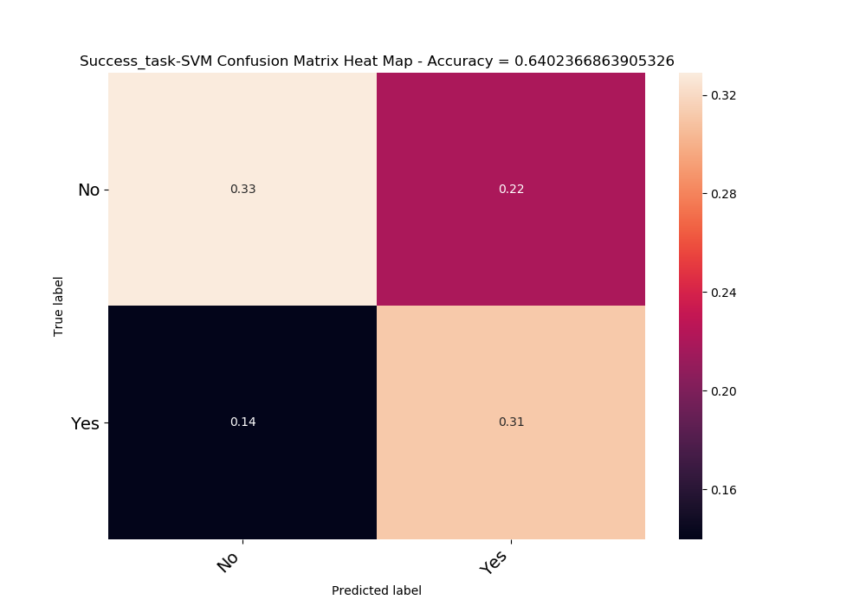

XGBOOST

The best parameters found by grid search are:

{'gamma': 6, 'learning_rate': 0.2, 'max_depth': 3, 'min_child_weight': 5, 'n_estimators': 1000, 'objective': 'binary:logistic'}  
AUC = 0.656803999870332

AUC

train_auc: 0.6478909648434714

test_auc: 0.6352916073968706

train_rho: 0.2938086012184547

test_rho: 0.26854045073216676

|  |  |  |
| --- | --- | --- |
|  | train accuracy | test accuracy |
| 0 | 0.648889 | 0.639053 |
| 1 | 0.663704 | 0.573964 |
| 2 | 0.625185 | 0.692308 |
| 3 | 0.663704 | 0.573964 |
| 4 | 0.64 | 0.680473 |
| average | 0.648296 | 0.631953 |
| AUC | 0.6478909 | 0.6352916 |

Confusion matrix

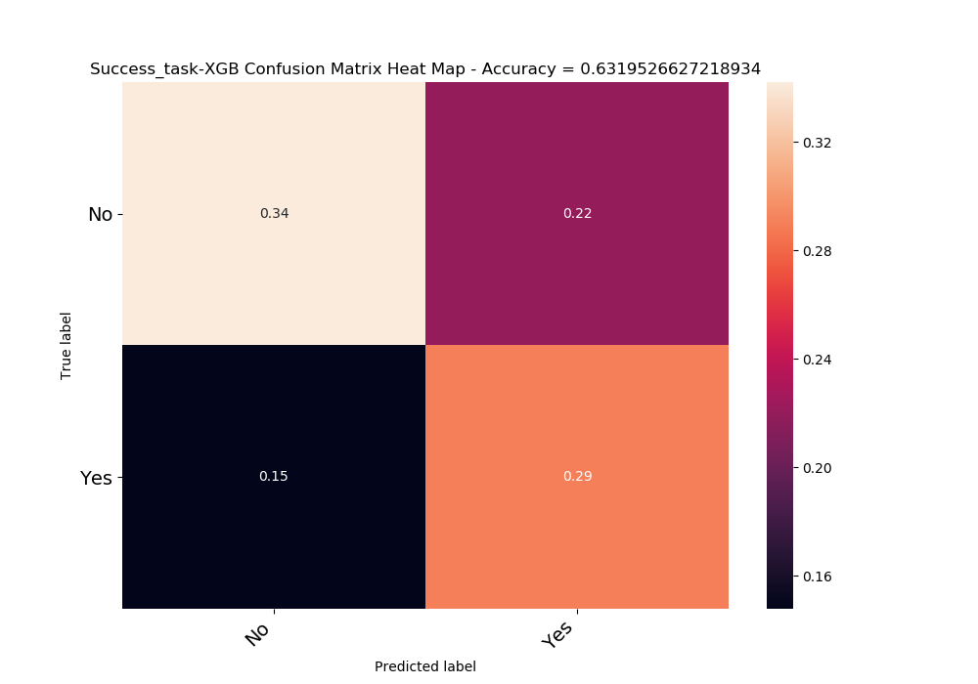

Previous - AUC

**train_auc: 0.6634364080439279**

**test_auc: 0.6171194879089615**

**train_rho: 0.3297514382495453**

**test_rho: 0.2371579927759326**

|  |  |  |
| --- | --- | --- |
|  | train accuracy | test accuracy |
| average | 0.649926 | 0.602959 |
| AUC | **0.6634364** | **0.6171194** |

Confusion matrix

|  |  |  |
| --- | --- | --- |
|  | No | Yes |
| No | 0.28284 | 0.27929 |
| Yes | 0.117751 | 0.320118 |
| acc | 0.602959 |  |

NN

Using Anna preprocess-

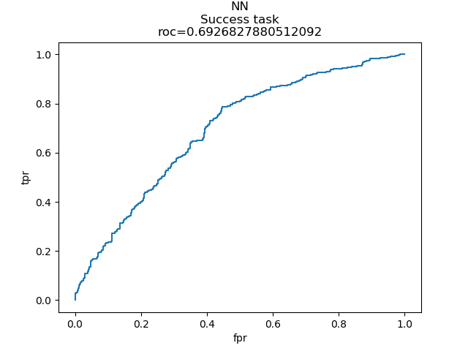

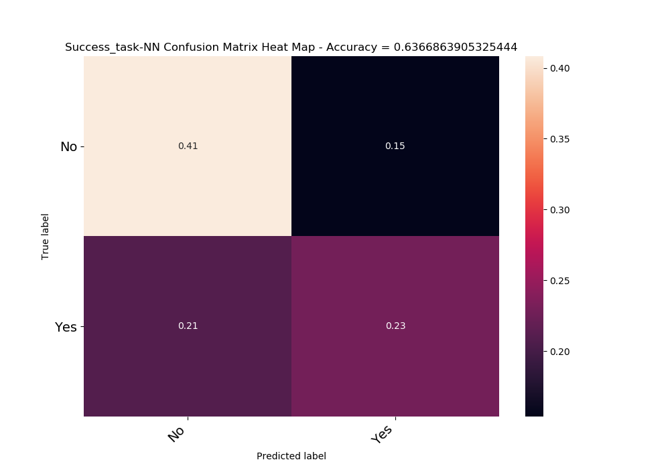

Prognostic distinction in allergic patients at day 0

Is patient in day 0 of treatment is seem to react to the treatment?

We wanted to check whether there was a difference in microbiome between the patients who responded to the treatment and were labeled A1 and the patients who did not respond to the treatment who were labeled otherwise.

We calculated the Rho values for the bacteria given their real tags and given random tags by mixing those tags but maintaining their distribution.

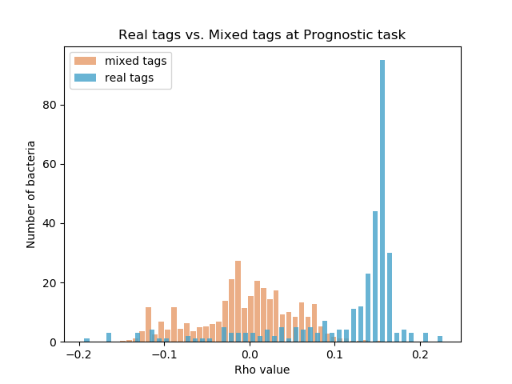

We were pleased to see that the dispersion was wider for the real tags, indicating a link between microbiome and the tags, this is in contrast to the narrower dispersion for mixed labels.

Significant bacteria –

|  |  |
| --- | --- |
| -0.19057 | k__Bacteria; p__Bacteroidetes; c__Bacteroidia; o__Bacteroidales; f__Rikenellaceae; g__ |
| -0.1649 | k__Bacteria; p__Bacteroidetes; c__Bacteroidia; o__Bacteroidales; f__Bacteroidaceae; g__Bacteroides |
| -0.16261 | k__Bacteria; p__Bacteroidetes; c__Bacteroidia; o__Bacteroidales; f__[Barnesiellaceae]; g__ |
| -0.15949 | k__Bacteria; p__Bacteroidetes; c__Bacteroidia; o__Bacteroidales; f__Porphyromonadaceae; g__Parabacteroides |
| -0.12833 | k__Bacteria; p__Firmicutes; c__Clostridia; o__Clostridiales; f__Christensenellaceae; g__ |
| -0.12558 | k__Bacteria; p__Proteobacteria; c__Deltaproteobacteria; o__Desulfovibrionales; f__Desulfovibrionaceae; g__Bilophila |
| -0.12384 | k__Bacteria; p__Proteobacteria; c__Betaproteobacteria; o__Burkholderiales; f__Oxalobacteraceae; g__Oxalobacter |
| 0.113663 | k__Bacteria; p__Firmicutes; c__Clostridia; o__Clostridiales; f__[Tissierellaceae]; g__Anaerococcus |
| 0.113755 | k__Bacteria; p__Proteobacteria; c__Deltaproteobacteria; o__Desulfovibrionales; f__Desulfovibrionaceae; g__ |
| 0.116505 | k__Bacteria; p__Firmicutes; c__Clostridia; o__Clostridiales; f__EtOH8; g__ |
| 0.119163 | k__Bacteria; p__Firmicutes; c__Clostridia; o__Clostridiales; f__[Mogibacteriaceae]; g__ |
| 0.121821 | k__Bacteria; p__Bacteroidetes; c__Bacteroidia; o__Bacteroidales; f__S24-7; g__ |
| 0.122096 | k__Bacteria; p__Firmicutes; c__Erysipelotrichi; o__Erysipelotrichales; f__Erysipelotrichaceae; g__Coprobacillus |
| 0.123746 | k__Bacteria; p__Proteobacteria; c__Gammaproteobacteria; o__Aeromonadales; f__Succinivibrionaceae; g__Succinivibrio |
| 0.123929 | k__Bacteria; p__Synergistetes; c__Synergistia; o__Synergistales; f__Synergistaceae; g__Cloacibacillus |
| 0.124846 | k__Bacteria; p__Firmicutes; c__Clostridia; o__Clostridiales; f__Veillonellaceae; g__Megamonas |
| 0.125854 | k__Bacteria; p__Firmicutes; c__Bacilli; o__Lactobacillales; f__Streptococcaceae; g__Lactococcus |
| 0.126129 | k__Bacteria; p__Firmicutes; c__Bacilli; o__Lactobacillales; f__Streptococcaceae; g__Streptococcus |
| 0.126129 | k__Bacteria; p__Firmicutes; c__Clostridia; o__Clostridiales; f__Dehalobacteriaceae; g__ |
| 0.127963 | k__Bacteria; p__Bacteroidetes; c__Bacteroidia; o__Bacteroidales; f__; g__ |
| 0.128329 | k__Bacteria; p__Firmicutes; c__Clostridia; o__Clostridiales; f__[Tissierellaceae]; g__ph2 |
| 0.129521 | k__Bacteria; p__Firmicutes; c__Clostridia; o__Clostridiales; f__[Mogibacteriaceae]; g__Mogibacterium |
| 0.130346 | k__Bacteria; p__Synergistetes; c__Synergistia; o__Synergistales; f__Dethiosulfovibrionaceae; g__Pyramidobacter |
| 0.130529 | k__Bacteria; p__Bacteroidetes; c__Bacteroidia; o__Bacteroidales; f__Prevotellaceae; g__ |
| 0.131629 | k__Bacteria; p__Bacteroidetes; c__Bacteroidia; o__Bacteroidales; f__[Paraprevotellaceae]; g__[Prevotella] |
| 0.132546 | k__Bacteria; p__Firmicutes; c__Clostridia; o__Clostridiales; f__[Tissierellaceae]; g__1-68 |
| 0.133371 | k__Bacteria; p__Actinobacteria; c__Actinobacteria; o__Bifidobacteriales; f__Bifidobacteriaceae; g__Bifidobacterium |
| 0.133737 | k__Bacteria; p__Firmicutes; c__Bacilli; o__Lactobacillales; f__Aerococcaceae; g__Abiotrophia |
| 0.134104 | k__Bacteria; p__Firmicutes; c__Bacilli; o__Bacillales; f__Staphylococcaceae; g__Staphylococcus |
| 0.136304 | k__Bacteria; p__Actinobacteria; c__Coriobacteriia; o__Coriobacteriales; f__Coriobacteriaceae |
| 0.136854 | k__Bacteria; p__Firmicutes; c__Bacilli; o__Bacillales; f__Bacillaceae; g__Bacillus |
| 0.137679 | k__Bacteria; p__Proteobacteria; c__Betaproteobacteria; o__Burkholderiales; f__Comamonadaceae; g__Comamonas |
| 0.138046 | k__Bacteria; p__Proteobacteria; c__Gammaproteobacteria; o__Pseudomonadales; f__Moraxellaceae; g__Acinetobacter |
| 0.138137 | k__Bacteria; p__Actinobacteria; c__Coriobacteriia; o__Coriobacteriales; f__Coriobacteriaceae; g__Collinsella |
| 0.138412 | k__Bacteria; p__Actinobacteria; c__Actinobacteria; o__Actinomycetales; f__Actinomycetaceae; g__Mobiluncus |
| 0.138962 | k__Bacteria; p__Proteobacteria; c__Betaproteobacteria; o__Burkholderiales |
| 0.140612 | k__Bacteria; p__Synergistetes; c__Synergistia; o__Synergistales; f__Synergistaceae; g__ |
| 0.140979 | k__Bacteria; p__Firmicutes; c__Clostridia; o__Clostridiales; f__Veillonellaceae; g__Mitsuokella |
| 0.141254 | k__Bacteria; p__Bacteroidetes; c__Flavobacteriia; o__Flavobacteriales; f__[Weeksellaceae]; g__ |
| 0.142079 | k__Bacteria; p__Actinobacteria; c__Actinobacteria; o__Actinomycetales; f__Actinomycetaceae; g__Varibaculum |
| 0.142079 | k__Bacteria; p__Firmicutes; c__Clostridia; o__Clostridiales; f__[Tissierellaceae]; g__Parvimonas |
| 0.142262 | k__Bacteria; p__Tenericutes; c__RF3; o__ML615J-28; f__; g__ |
| 0.145104 | k__Bacteria; p__Firmicutes; c__Erysipelotrichi; o__Erysipelotrichales; f__Erysipelotrichaceae; g__Bulleidia |
| 0.146845 | k__Bacteria; p__Proteobacteria; c__Epsilonproteobacteria; o__Campylobacterales; f__Campylobacteraceae; g__Campylobacter |
| 0.14767 | k__Bacteria; p__Actinobacteria; c__Actinobacteria; o__Actinomycetales; f__Intrasporangiaceae |
| 0.14767 | k__Bacteria; p__Bacteroidetes; c__Bacteroidia; o__Bacteroidales; f__Porphyromonadaceae; g__Dysgonomonas |
| 0.14767 | k__Bacteria; p__Bacteroidetes; c__Cytophagia; o__Cytophagales; f__Cytophagaceae; g__Leadbetterella |
| 0.14767 | k__Bacteria; p__Bacteroidetes; c__Sphingobacteriia; o__Sphingobacteriales; f__Sphingobacteriaceae; g__Sphingobacterium |
| 0.14767 | k__Bacteria; p__Firmicutes; c__Bacilli; o__Lactobacillales; f__Aerococcaceae; g__Facklamia |
| 0.14767 | k__Bacteria; p__Firmicutes; c__Bacilli; o__Lactobacillales; f__Carnobacteriaceae; g__Trichococcus |
| 0.14767 | k__Bacteria; p__Proteobacteria; c__Alphaproteobacteria; o__Rhizobiales; f__Rhizobiaceae; g__Shinella |
| 0.14767 | k__Bacteria; p__Proteobacteria; c__Alphaproteobacteria; o__Rhodobacterales; f__Rhodobacteraceae; g__Paracoccus |
| 0.14767 | k__Bacteria; p__Proteobacteria; c__Gammaproteobacteria; o__Pseudomonadales; f__Pseudomonadaceae |
| 0.14767 | k__Bacteria; p__Proteobacteria; c__Gammaproteobacteria; o__Xanthomonadales; f__Xanthomonadaceae; g__Stenotrophomonas |
| 0.14767 | k__Bacteria; p__SR1; c__; o__; f__; g__ |
| 0.147762 | k__Bacteria; p__Bacteroidetes; c__Bacteroidia; o__Bacteroidales; f__Porphyromonadaceae; g__Paludibacter |
| 0.147762 | k__Bacteria; p__Firmicutes; c__Bacilli; o__Bacillales |
| 0.147762 | k__Bacteria; p__Proteobacteria; c__Alphaproteobacteria; o__Rhizobiales; f__Methylobacteriaceae; g__ |
| 0.147762 | k__Bacteria; p__Spirochaetes; c__Spirochaetes; o__Spirochaetales; f__Spirochaetaceae; g__Treponema |
| 0.147945 | k__Bacteria; p__Firmicutes; c__Bacilli; o__Lactobacillales; f__Aerococcaceae; g__Alloiococcus |
| 0.147945 | k__Bacteria; p__Fusobacteria; c__Fusobacteriia; o__Fusobacteriales; f__Leptotrichiaceae; g__Leptotrichia |
| 0.147945 | k__Bacteria; p__Verrucomicrobia; c__Opitutae; o__[Cerasicoccales]; f__[Cerasicoccaceae]; g__ |
| 0.148037 | k__Bacteria; p__Firmicutes; c__Clostridia; o__Clostridiales; f__Ruminococcaceae; g__Clostridium |
| 0.148129 | k__Bacteria; p__Firmicutes; c__Clostridia; o__Clostridiales; f__Peptococcaceae; g__rc4-4 |
| 0.14822 | k__Bacteria; p__Proteobacteria; c__Alphaproteobacteria; o__Rhodobacterales; f__Rhodobacteraceae |
| 0.148587 | k__Bacteria; p__Proteobacteria; c__Alphaproteobacteria; o__Caulobacterales; f__Caulobacteraceae |
| 0.149412 | k__Bacteria; p__Firmicutes; c__Clostridia; o__Clostridiales; f__Lachnospiraceae; g__Pseudobutyrivibrio |
| 0.149412 | k__Bacteria; p__Firmicutes; c__Clostridia; o__Clostridiales; f__Peptostreptococcaceae; g__[Clostridium] |
| 0.149504 | k__Bacteria; p__Firmicutes; c__Bacilli; o__Bacillales; f__Bacillaceae |
| 0.149687 | k__Bacteria; p__Proteobacteria; c__Betaproteobacteria; o__Burkholderiales; f__Oxalobacteraceae |
| 0.14987 | k__Bacteria; p__Bacteroidetes; c__Bacteroidia; o__Bacteroidales; f__Rikenellaceae; g__Rikenella |
| 0.150054 | k__Bacteria; p__Firmicutes; c__Bacilli; o__Gemellales; f__Gemellaceae; g__ |
| 0.150512 | k__Bacteria; p__Proteobacteria; c__Betaproteobacteria; o__Neisseriales; f__Neisseriaceae; g__Kingella |
| 0.150604 | k__Bacteria; p__Firmicutes; c__Bacilli; o__Lactobacillales; f__Leuconostocaceae; g__Weissella |
| 0.150604 | k__Bacteria; p__Firmicutes; c__Clostridia; o__Clostridiales; f__Ruminococcaceae; g__Butyricicoccus |
| 0.150604 | k__Bacteria; p__Proteobacteria; c__Gammaproteobacteria; o__Enterobacteriales; f__Enterobacteriaceae; g__Yersinia |
| 0.150695 | k__Bacteria; p__Proteobacteria; c__Gammaproteobacteria; o__Pseudomonadales; f__Pseudomonadaceae; g__Pseudomonas |
| 0.150879 | k__Bacteria; p__Actinobacteria; c__Actinobacteria; o__Bifidobacteriales; f__Bifidobacteriaceae; g__Scardovia |
| 0.151245 | k__Bacteria; p__Proteobacteria; c__Betaproteobacteria; o__Burkholderiales; f__Burkholderiaceae; g__Lautropia |
| 0.151429 | k__Bacteria; p__Actinobacteria |
| 0.151429 | k__Bacteria; p__Proteobacteria; c__Alphaproteobacteria; o__Rhizobiales; f__Brucellaceae; g__Ochrobactrum |
| 0.151429 | k__Bacteria; p__Proteobacteria; c__Betaproteobacteria; o__Burkholderiales; f__Alcaligenaceae; g__Achromobacter |
| 0.151429 | k__Bacteria; p__Proteobacteria; c__Betaproteobacteria; o__Burkholderiales; f__Comamonadaceae; g__Delftia |
| 0.15152 | k__Bacteria; p__Bacteroidetes |
| 0.15152 | k__Bacteria; p__Synergistetes; c__Synergistia; o__Synergistales; f__Synergistaceae; g__Synergistes |
| 0.151612 | k__Bacteria; p__Firmicutes; c__Clostridia; o__Clostridiales; f__Veillonellaceae; g__Selenomonas |
| 0.151704 | k__Bacteria; p__[Thermi]; c__Deinococci; o__Thermales; f__Thermaceae; g__Thermus |
| 0.151795 | k__Bacteria; p__Proteobacteria; c__Alphaproteobacteria; o__Rhizobiales; f__Hyphomicrobiaceae; g__Devosia |
| 0.15207 | k__Bacteria; p__Tenericutes; c__Mollicutes; o__Anaeroplasmatales; f__Anaeroplasmataceae; g__ |
| 0.152254 | k__Bacteria; p__Firmicutes; c__Bacilli; o__Bacillales; f__Staphylococcaceae; g__Jeotgalicoccus |
| 0.152345 | k__Bacteria; p__Bacteroidetes; c__Bacteroidia; o__Bacteroidales; f__[Paraprevotellaceae]; g__ |
| 0.152437 | k__Bacteria; p__Proteobacteria; c__Gammaproteobacteria; o__Enterobacteriales; f__Enterobacteriaceae; g__Enterobacter |
| 0.152895 | k__Bacteria; p__Proteobacteria; c__Betaproteobacteria; o__Neisseriales; f__Neisseriaceae |
| 0.153262 | k__Bacteria; p__Firmicutes; c__Clostridia; o__Clostridiales; f__Lachnospiraceae; g__Butyrivibrio |
| 0.153262 | k__Bacteria; p__Firmicutes; c__Clostridia; o__Clostridiales; f__Veillonellaceae; g__Schwartzia |
| 0.153353 | k__Archaea; p__Euryarchaeota; c__Methanobacteria; o__Methanobacteriales; f__Methanobacteriaceae; g__Methanosphaera |
| 0.153537 | k__Bacteria; p__Lentisphaerae; c__[Lentisphaeria]; o__Victivallales; f__Victivallaceae; g__ |
| 0.153812 | k__Bacteria; p__Firmicutes; c__Clostridia; o__Clostridiales; f__Lachnospiraceae; g__Catonella |
| 0.153812 | k__Bacteria; p__Firmicutes; c__Clostridia; o__Clostridiales; f__Lachnospiraceae; g__Moryella |
| 0.154362 | k__Bacteria; p__Fusobacteria; c__Fusobacteriia; o__Fusobacteriales; f__Leptotrichiaceae; g__ |
| 0.154453 | k__Bacteria; p__Firmicutes; c__Clostridia; o__Clostridiales; f__Clostridiaceae |
| 0.15482 | k__Bacteria; p__Bacteroidetes; c__[Saprospirae]; o__[Saprospirales]; f__Chitinophagaceae; g__Sediminibacterium |
| 0.156103 | k__Bacteria; p__Proteobacteria; c__Gammaproteobacteria; o__Enterobacteriales; f__Enterobacteriaceae; g__Proteus |
| 0.156837 | k__Bacteria; p__Firmicutes; c__Clostridia; o__Clostridiales; f__Ruminococcaceae; g__Ethanoligenens |
| 0.157295 | k__Bacteria; p__Firmicutes; c__Clostridia; o__Clostridiales; f__Peptococcaceae; g__Peptococcus |
| 0.157478 | k__Bacteria; p__Proteobacteria; c__Gammaproteobacteria; o__Enterobacteriales; f__Enterobacteriaceae; g__Shigella |
| 0.157662 | k__Archaea |
| 0.157662 | k__Bacteria; p__Actinobacteria; c__Actinobacteria; o__Actinomycetales; f__Dermabacteraceae; g__Dermabacter |
| 0.157662 | k__Bacteria; p__Actinobacteria; c__Actinobacteria; o__Actinomycetales; f__Microbacteriaceae |
| 0.157662 | k__Bacteria; p__Actinobacteria; c__Actinobacteria; o__Actinomycetales; f__Microbacteriaceae; g__Leucobacter |
| 0.157662 | k__Bacteria; p__Actinobacteria; c__Actinobacteria; o__Actinomycetales; f__Micrococcaceae |
| 0.157662 | k__Bacteria; p__Actinobacteria; c__Actinobacteria; o__Actinomycetales; f__Pseudonocardiaceae |
| 0.157662 | k__Bacteria; p__Actinobacteria; c__Actinobacteria; o__Bifidobacteriales; f__Bifidobacteriaceae |
| 0.157662 | k__Bacteria; p__Bacteroidetes; c__Bacteroidia; o__Bacteroidales; f__Porphyromonadaceae |
| 0.157662 | k__Bacteria; p__Bacteroidetes; c__Bacteroidia; o__Bacteroidales; f__[Paraprevotellaceae]; g__CF231 |
| 0.157662 | k__Bacteria; p__Bacteroidetes; c__Flavobacteriia; o__Flavobacteriales; f__Flavobacteriaceae; g__Flavobacterium |
| 0.157662 | k__Bacteria; p__Bacteroidetes; c__Flavobacteriia; o__Flavobacteriales; f__[Weeksellaceae]; g__Chryseobacterium |
| 0.157662 | k__Bacteria; p__Bacteroidetes; c__Flavobacteriia; o__Flavobacteriales; f__[Weeksellaceae]; g__Wautersiella |
| 0.157662 | k__Bacteria; p__Bacteroidetes; c__Sphingobacteriia; o__Sphingobacteriales; f__Sphingobacteriaceae; g__Pedobacter |
| 0.157662 | k__Bacteria; p__Chloroflexi; c__Anaerolineae; o__GCA004; f__; g__ |
| 0.157662 | k__Bacteria; p__Chloroflexi; c__Thermomicrobia; o__AKYG1722; f__; g__ |
| 0.157662 | k__Bacteria; p__Cyanobacteria; c__Oscillatoriophycideae; o__Oscillatoriales; f__Phormidiaceae; g__Phormidium |
| 0.157662 | k__Bacteria; p__Firmicutes; c__Bacilli |
| 0.157662 | k__Bacteria; p__Firmicutes; c__Bacilli; o__Bacillales; f__Bacillaceae; g__Geobacillus |
| 0.157662 | k__Bacteria; p__Firmicutes; c__Bacilli; o__Bacillales; f__Paenibacillaceae; g__Paenibacillus |
| 0.157662 | k__Bacteria; p__Firmicutes; c__Bacilli; o__Lactobacillales; f__Lactobacillaceae |
| 0.157662 | k__Bacteria; p__Firmicutes; c__Clostridia; o__Clostridiales; f__Christensenellaceae |
| 0.157662 | k__Bacteria; p__Firmicutes; c__Clostridia; o__Clostridiales; f__Clostridiaceae; g__02d06 |
| 0.157662 | k__Bacteria; p__Firmicutes; c__Clostridia; o__Clostridiales; f__Lachnospiraceae; g__Oribacterium |
| 0.157662 | k__Bacteria; p__Firmicutes; c__Clostridia; o__Clostridiales; f__Ruminococcaceae; g__Gemmiger |
| 0.157662 | k__Bacteria; p__Firmicutes; c__Clostridia; o__Clostridiales; f__Ruminococcaceae; g__Sporobacter |
| 0.157662 | k__Bacteria; p__Firmicutes; c__Clostridia; o__Clostridiales; f__Veillonellaceae |
| 0.157662 | k__Bacteria; p__Firmicutes; c__Clostridia; o__Clostridiales; f__Veillonellaceae; g__ |
| 0.157662 | k__Bacteria; p__Firmicutes; c__Clostridia; o__Clostridiales; f__[Acidaminobacteraceae]; g__ |
| 0.157662 | k__Bacteria; p__Firmicutes; c__Clostridia; o__Clostridiales; f__[Mogibacteriaceae]; g__Anaerovorax |
| 0.157662 | k__Bacteria; p__Firmicutes; c__Clostridia; o__Clostridiales; f__[Tissierellaceae]; g__ |
| 0.157662 | k__Bacteria; p__Firmicutes; c__Erysipelotrichi; o__Erysipelotrichales; f__Erysipelotrichaceae; g__Clostridium |
| 0.157662 | k__Bacteria; p__Fusobacteria; c__Fusobacteriia; o__Fusobacteriales; f__Leptotrichiaceae; g__Sneathia |
| 0.157662 | k__Bacteria; p__Lentisphaerae; c__[Lentisphaeria]; o__Victivallales; f__Victivallaceae; g__Victivallis |
| 0.157662 | k__Bacteria; p__Proteobacteria |
| 0.157662 | k__Bacteria; p__Proteobacteria; c__Alphaproteobacteria; o__BD7-3; f__; g__ |
| 0.157662 | k__Bacteria; p__Proteobacteria; c__Alphaproteobacteria; o__Caulobacterales; f__Caulobacteraceae; g__ |
| 0.157662 | k__Bacteria; p__Proteobacteria; c__Alphaproteobacteria; o__Caulobacterales; f__Caulobacteraceae; g__Mycoplana |
| 0.157662 | k__Bacteria; p__Proteobacteria; c__Alphaproteobacteria; o__Rhizobiales; f__Bradyrhizobiaceae; g__Balneimonas |
| 0.157662 | k__Bacteria; p__Proteobacteria; c__Alphaproteobacteria; o__Rhizobiales; f__Brucellaceae |
| 0.157662 | k__Bacteria; p__Proteobacteria; c__Alphaproteobacteria; o__Rhizobiales; f__Hyphomicrobiaceae; g__ |
| 0.157662 | k__Bacteria; p__Proteobacteria; c__Alphaproteobacteria; o__Rhizobiales; f__Rhizobiaceae; g__ |
| 0.157662 | k__Bacteria; p__Proteobacteria; c__Alphaproteobacteria; o__Rhizobiales; f__Rhizobiaceae; g__Agrobacterium |
| 0.157662 | k__Bacteria; p__Proteobacteria; c__Alphaproteobacteria; o__Rhizobiales; f__Rhizobiaceae; g__Rhizobium |
| 0.157662 | k__Bacteria; p__Proteobacteria; c__Alphaproteobacteria; o__Rhodobacterales; f__Rhodobacteraceae; g__Amaricoccus |
| 0.157662 | k__Bacteria; p__Proteobacteria; c__Alphaproteobacteria; o__Rhodospirillales; f__Acetobacteraceae; g__ |
| 0.157662 | k__Bacteria; p__Proteobacteria; c__Alphaproteobacteria; o__Rhodospirillales; f__Acetobacteraceae; g__Gluconobacter |
| 0.157662 | k__Bacteria; p__Proteobacteria; c__Alphaproteobacteria; o__Rickettsiales; f__Rickettsiaceae; g__Wolbachia |
| 0.157662 | k__Bacteria; p__Proteobacteria; c__Alphaproteobacteria; o__Sphingomonadales; f__; g__ |
| 0.157662 | k__Bacteria; p__Proteobacteria; c__Alphaproteobacteria; o__Sphingomonadales; f__Sphingomonadaceae |
| 0.157662 | k__Bacteria; p__Proteobacteria; c__Alphaproteobacteria; o__Sphingomonadales; f__Sphingomonadaceae; g__Novosphingobium |
| 0.157662 | k__Bacteria; p__Proteobacteria; c__Alphaproteobacteria; o__Sphingomonadales; f__Sphingomonadaceae; g__Sphingobium |
| 0.157662 | k__Bacteria; p__Proteobacteria; c__Alphaproteobacteria; o__Sphingomonadales; f__Sphingomonadaceae; g__Sphingopyxis |
| 0.157662 | k__Bacteria; p__Proteobacteria; c__Betaproteobacteria; o__Burkholderiales; f__Alcaligenaceae; g__ |
| 0.157662 | k__Bacteria; p__Proteobacteria; c__Betaproteobacteria; o__Burkholderiales; f__Alcaligenaceae; g__Alcaligenes |
| 0.157662 | k__Bacteria; p__Proteobacteria; c__Betaproteobacteria; o__Burkholderiales; f__Burkholderiaceae |
| 0.157662 | k__Bacteria; p__Proteobacteria; c__Betaproteobacteria; o__Burkholderiales; f__Oxalobacteraceae; g__Cupriavidus |
| 0.157662 | k__Bacteria; p__Proteobacteria; c__Betaproteobacteria; o__Burkholderiales; f__Oxalobacteraceae; g__Janthinobacterium |
| 0.157662 | k__Bacteria; p__Proteobacteria; c__Betaproteobacteria; o__Neisseriales; f__Neisseriaceae; g__Eikenella |
| 0.157662 | k__Bacteria; p__Proteobacteria; c__Betaproteobacteria; o__Rhodocyclales; f__Rhodocyclaceae; g__Dok59 |
| 0.157662 | k__Bacteria; p__Proteobacteria; c__Betaproteobacteria; o__Rhodocyclales; f__Rhodocyclaceae; g__Thauera |
| 0.157662 | k__Bacteria; p__Proteobacteria; c__Epsilonproteobacteria; o__Campylobacterales; f__Helicobacteraceae; g__Flexispira |
| 0.157662 | k__Bacteria; p__Proteobacteria; c__Gammaproteobacteria; o__Aeromonadales; f__Succinivibrionaceae |
| 0.157662 | k__Bacteria; p__Proteobacteria; c__Gammaproteobacteria; o__Aeromonadales; f__Succinivibrionaceae; g__ |
| 0.157662 | k__Bacteria; p__Proteobacteria; c__Gammaproteobacteria; o__Enterobacteriales; f__Enterobacteriaceae; g__Erwinia |
| 0.157662 | k__Bacteria; p__Proteobacteria; c__Gammaproteobacteria; o__Enterobacteriales; f__Enterobacteriaceae; g__Plesiomonas |
| 0.157662 | k__Bacteria; p__Proteobacteria; c__Gammaproteobacteria; o__Enterobacteriales; f__Enterobacteriaceae; g__Providencia |
| 0.157662 | k__Bacteria; p__Proteobacteria; c__Gammaproteobacteria; o__Enterobacteriales; f__Enterobacteriaceae; g__Sodalis |
| 0.157662 | k__Bacteria; p__Proteobacteria; c__Gammaproteobacteria; o__Enterobacteriales; f__Enterobacteriaceae; g__Trabulsiella |
| 0.157662 | k__Bacteria; p__Proteobacteria; c__Gammaproteobacteria; o__Pseudomonadales; f__Moraxellaceae; g__Enhydrobacter |
| 0.157662 | k__Bacteria; p__Proteobacteria; c__Gammaproteobacteria; o__Xanthomonadales; f__Xanthomonadaceae; g__Pseudoxanthomonas |
| 0.157662 | k__Bacteria; p__TM7; c__TM7-3; o__CW040; f__F16; g__ |
| 0.157662 | k__Bacteria; p__Tenericutes; c__Mollicutes; o__Mycoplasmatales; f__Mycoplasmataceae; g__Mycoplasma |
| 0.157662 | k__Bacteria; p__Verrucomicrobia; c__Opitutae; o__HA64; f__; g__ |
| 0.157662 | k__Bacteria; p__Verrucomicrobia; c__Verrucomicrobiae; o__Verrucomicrobiales; f__Verrucomicrobiaceae; g__Prosthecobacter |
| 0.157753 | k__Bacteria; p__Firmicutes; c__Clostridia; o__Clostridiales; f__[Tissierellaceae]; g__Peptoniphilus |
| 0.158762 | k__Bacteria; p__Fusobacteria; c__Fusobacteriia; o__Fusobacteriales; f__Fusobacteriaceae; g__Fusobacterium |
| 0.159037 | k__Bacteria; p__Firmicutes; c__Bacilli; o__Lactobacillales |
| 0.159128 | k__Bacteria; p__Firmicutes; c__Clostridia; o__Clostridiales; f__Peptostreptococcaceae |
| 0.159128 | k__Bacteria; p__Proteobacteria; c__Betaproteobacteria; o__Burkholderiales; f__Burkholderiaceae; g__Burkholderia |
| 0.159128 | k__Bacteria; p__Proteobacteria; c__Gammaproteobacteria; o__Enterobacteriales; f__Enterobacteriaceae; g__Serratia |
| 0.159678 | k__Bacteria; p__Proteobacteria; c__Gammaproteobacteria; o__Pasteurellales; f__Pasteurellaceae |
| 0.159862 | k__Bacteria; p__Firmicutes; c__Bacilli; o__Gemellales; f__Gemellaceae; g__Gemella |
| 0.160687 | k__Bacteria; p__Firmicutes; c__Erysipelotrichi; o__Erysipelotrichales; f__Erysipelotrichaceae; g__RFN20 |
| 0.160778 | k__Bacteria; p__Firmicutes; c__Clostridia; o__Clostridiales; f__Lachnospiraceae; g__Epulopiscium |
| 0.160962 | k__Bacteria; p__Bacteroidetes; c__Bacteroidia; o__Bacteroidales; f__[Paraprevotellaceae]; g__YRC22 |
| 0.161145 | k__Bacteria; p__Acidobacteria; c__Acidobacteria-6; o__iii1-15; f__mb2424; g__ |
| 0.161512 | k__Bacteria; p__Proteobacteria; c__Betaproteobacteria; o__Burkholderiales; f__Comamonadaceae |
| 0.162245 | k__Bacteria; p__Firmicutes; c__Clostridia; o__Clostridiales; f__Veillonellaceae; g__Succiniclasticum |
| 0.162612 | k__Bacteria; p__Proteobacteria; c__Gammaproteobacteria; o__Cardiobacteriales; f__Cardiobacteriaceae; g__Cardiobacterium |
| 0.163161 | k__Bacteria; p__Firmicutes; c__Clostridia; o__Clostridiales; f__[Tissierellaceae]; g__Finegoldia |
| 0.163711 | k__Bacteria; p__Bacteroidetes; c__Bacteroidia; o__Bacteroidales; f__Prevotellaceae |
| 0.163711 | k__Bacteria; p__[Thermi]; c__Deinococci; o__Deinococcales; f__Deinococcaceae; g__R18-435 |
| 0.164995 | k__Bacteria; p__Bacteroidetes; c__Bacteroidia; o__Bacteroidales; f__Rikenellaceae |
| 0.16637 | k__Bacteria; p__Proteobacteria; c__Alphaproteobacteria; o__Rhodospirillales; f__Acetobacteraceae; g__Acetobacter |
| 0.16747 | k__Bacteria; p__Bacteroidetes; c__Bacteroidia; o__Bacteroidales; f__Rikenellaceae; g__AF12 |
| 0.167745 | k__Bacteria; p__Actinobacteria; c__Actinobacteria; o__Actinomycetales; f__Nocardiaceae; g__Rhodococcus |
| 0.16857 | k__Bacteria; p__Bacteroidetes; c__[Saprospirae]; o__[Saprospirales]; f__Chitinophagaceae; g__ |
| 0.169578 | k__Bacteria; p__Fusobacteria; c__Fusobacteriia; o__Fusobacteriales; f__Fusobacteriaceae; g__Cetobacterium |
| 0.16967 | k__Bacteria; p__Synergistetes; c__Synergistia; o__Synergistales; f__Dethiosulfovibrionaceae; g__TG5 |
| 0.170128 | k__Bacteria; p__Actinobacteria; c__Actinobacteria; o__Bifidobacteriales; f__Bifidobacteriaceae; g__Alloscardovia |
| 0.170311 | k__Bacteria; p__Proteobacteria; c__Betaproteobacteria; o__Neisseriales; f__Neisseriaceae; g__ |
| 0.17077 | k__Bacteria; p__Proteobacteria; c__Deltaproteobacteria; o__Bdellovibrionales; f__Bdellovibrionaceae; g__Bdellovibrio |
| 0.171228 | k__Bacteria; p__Chloroflexi; c__Anaerolineae; o__SBR1031; f__A4b; g__ |
| 0.171228 | k__Bacteria; p__Proteobacteria; c__Alphaproteobacteria; o__Rhizobiales; f__Phyllobacteriaceae; g__ |
| 0.171228 | k__Bacteria; p__Proteobacteria; c__Betaproteobacteria; o__Burkholderiales; f__Comamonadaceae; g__Methylibium |
| 0.171228 | k__Bacteria; p__Proteobacteria; c__Deltaproteobacteria; o__Myxococcales; f__; g__ |
| 0.171503 | k__Bacteria; p__Cyanobacteria; c__ML635J-21; o__; f__; g__ |
| 0.171503 | k__Bacteria; p__Proteobacteria; c__Alphaproteobacteria; o__Caulobacterales; f__Caulobacteraceae; g__Brevundimonas |
| 0.171503 | k__Bacteria; p__Proteobacteria; c__Alphaproteobacteria; o__Rhizobiales |
| 0.171503 | k__Bacteria; p__Proteobacteria; c__Alphaproteobacteria; o__Rhizobiales; f__; g__ |
| 0.171503 | k__Bacteria; p__Proteobacteria; c__Alphaproteobacteria; o__Rhodobacterales; f__Rhodobacteraceae; g__Rhodobacter |
| 0.171503 | k__Bacteria; p__Proteobacteria; c__Alphaproteobacteria; o__Sphingomonadales; f__Sphingomonadaceae; g__ |
| 0.171503 | k__Bacteria; p__WPS-2; c__; o__; f__; g__ |
| 0.172053 | k__Bacteria; p__TM7; c__TM7-3; o__; f__; g__ |
| 0.172236 | k__Bacteria; p__Deferribacteres; c__Deferribacteres; o__Deferribacterales; f__Deferribacteraceae; g__Mucispirillum |
| 0.172695 | k__Bacteria; p__Actinobacteria; c__Thermoleophilia; o__Solirubrobacterales; f__Conexibacteraceae; g__ |
| 0.172695 | k__Bacteria; p__Bacteroidetes; c__Flavobacteriia; o__Flavobacteriales; f__Flavobacteriaceae; g__Capnocytophaga |
| 0.173061 | k__Bacteria; p__Firmicutes; c__Clostridia; o__Clostridiales; f__[Tissierellaceae]; g__Gallicola |
| 0.173061 | k__Bacteria; p__Firmicutes; c__Erysipelotrichi; o__Erysipelotrichales; f__Erysipelotrichaceae; g__Allobaculum |
| 0.173061 | k__Bacteria; p__Proteobacteria; c__Epsilonproteobacteria; o__Campylobacterales; f__Helicobacteraceae |
| 0.173061 | k__Bacteria; p__Proteobacteria; c__Epsilonproteobacteria; o__Campylobacterales; f__Helicobacteraceae; g__Helicobacter |
| 0.173153 | k__Bacteria; p__Firmicutes; c__Erysipelotrichi; o__Erysipelotrichales; f__Erysipelotrichaceae; g__[Eubacterium] |
| 0.174894 | k__Bacteria; p__Proteobacteria; c__Gammaproteobacteria; o__Enterobacteriales; f__Enterobacteriaceae; g__Citrobacter |
| 0.176544 | k__Bacteria; p__Firmicutes; c__Bacilli; o__Lactobacillales; f__Leuconostocaceae; g__ |
| 0.179111 | k__Bacteria; p__Tenericutes; c__Mollicutes; o__Anaeroplasmatales; f__Anaeroplasmataceae; g__Anaeroplasma |
| 0.182869 | k__Bacteria; p__Bacteroidetes; c__Bacteroidia; o__Bacteroidales |
| 0.185711 | k__Bacteria; p__Firmicutes; c__Bacilli; o__Lactobacillales; f__Leuconostocaceae; g__Leuconostoc |
| 0.186169 | k__Bacteria; p__Firmicutes; c__Clostridia; o__Clostridiales; f__Lachnospiraceae; g__Blautia |
| 0.186719 | k__Bacteria; p__Firmicutes; c__Clostridia; o__Clostridiales; f__Peptostreptococcaceae; g__Peptostreptococcus |
| 0.190752 | k__Bacteria; p__Firmicutes; c__Erysipelotrichi; o__Erysipelotrichales; f__Erysipelotrichaceae; g__ |
| 0.191944 | k__Bacteria; p__Firmicutes; c__Bacilli; o__Lactobacillales; f__Enterococcaceae; g__Enterococcus |
| 0.19781 | k__Bacteria; p__Firmicutes; c__Clostridia; o__Clostridiales; f__Lachnospiraceae; g__[Ruminococcus] |
| 0.210277 | k__Bacteria; p__Actinobacteria; c__Coriobacteriia; o__Coriobacteriales; f__Coriobacteriaceae; g__ |
| 0.215227 | k__Bacteria; p__Actinobacteria; c__Coriobacteriia; o__Coriobacteriales; f__Coriobacteriaceae; g__Atopobium |
| 0.215593 | k__Bacteria; p__Firmicutes; c__Clostridia; o__Clostridiales; f__Lachnospiraceae; g__Coprococcus |
| 0.227051 | k__Bacteria; p__Firmicutes; c__Clostridia; o__Clostridiales; f__Lachnospiraceae; g__Dorea |
| 0.232551 | k__Bacteria; p__Proteobacteria; c__Alphaproteobacteria; o__Rhizobiales; f__Bradyrhizobiaceae; g__Bradyrhizobium |

Significant bacteria –

~~SVM~~

XGBOOST

Using anna preprocess didn’t improve the results.

The best parameters found by grid search are:

{'gamma': 3, 'learning_rate': 0.2, 'max_depth': 3, 'min_child_weight': 7, 'n_estimators': 1000, 'objective': 'binary:logistic'}

AUC

**train_auc: 0.6529426729986432**

**test_auc: 0.6387700534759359**

**train_rho: 0.3107323599277604**

**test_rho: 0.2789533711169917**

|  |  |  |
| --- | --- | --- |
|  | train accuracy | test accuracy |
| 0 | 0.662162 | 0.589286 |
| 1 | 0.68018 | 0.535714 |
| 2 | 0.612613 | 0.678571 |
| 3 | 0.608108 | 0.535714 |
| 4 | 0.585586 | 0.625 |
| 5 | 0.59009 | 0.607143 |
| 6 | 0.603604 | 0.553571 |
| 7 | 0.684685 | 0.642857 |
| 8 | 0.558559 | 0.732143 |
| 9 | 0.599099 | 0.571429 |
| average | 0.618468 | 0.607143 |
| AUC | **0.6529426** | **0.6387700** |

Confusion matrix

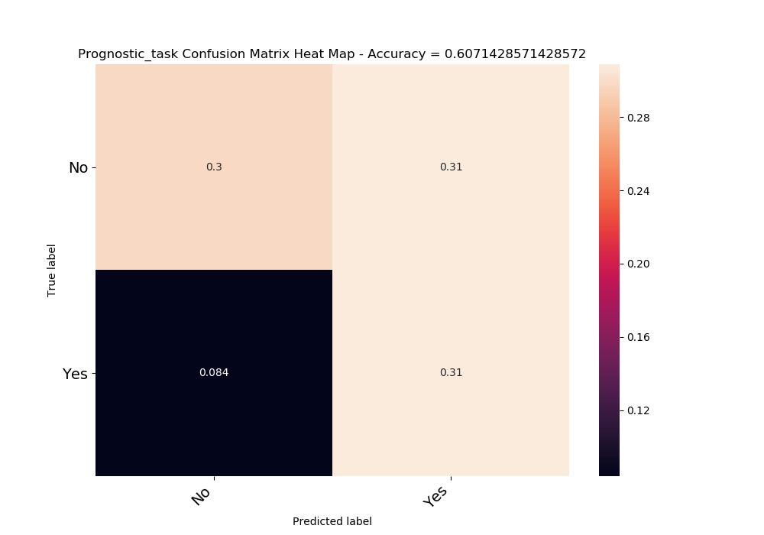

|  |  |  |
| --- | --- | --- |
|  | No | Yes |
| No | 0.298214 | 0.308929 |
| Yes | 0.083929 | 0.308929 |
| acc | 0.607143 |  |

NN

Using Anna preprocess-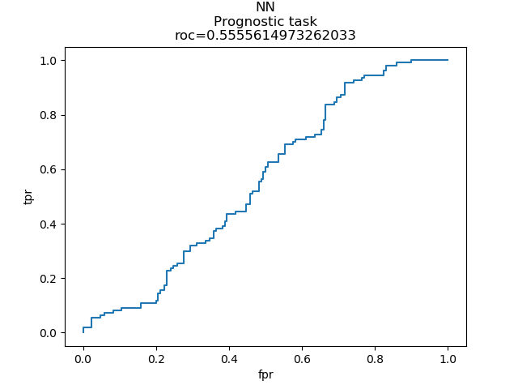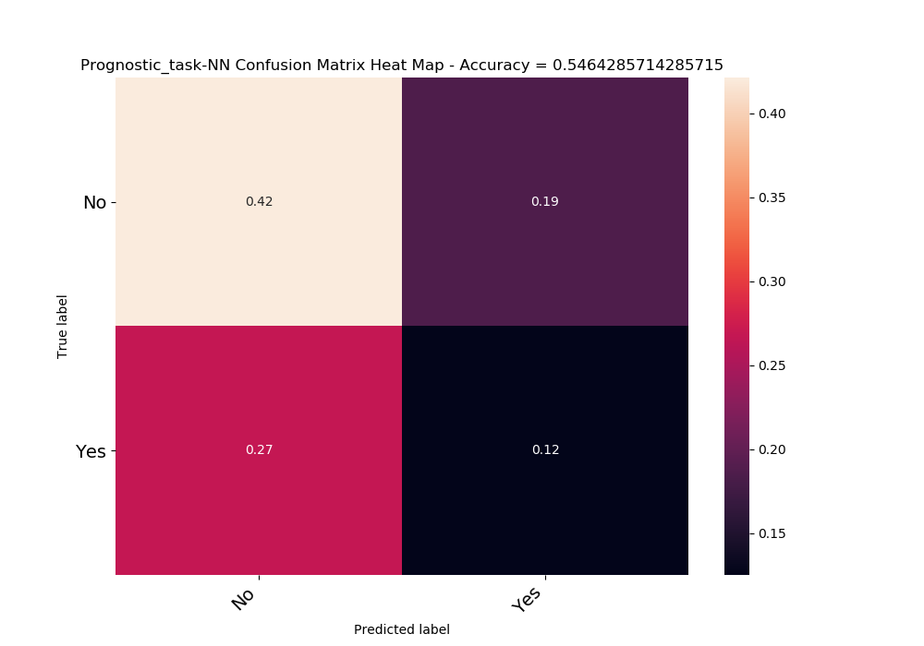

## Distinction between milk allergy to other allergies

Is patient allergic to milk or not?

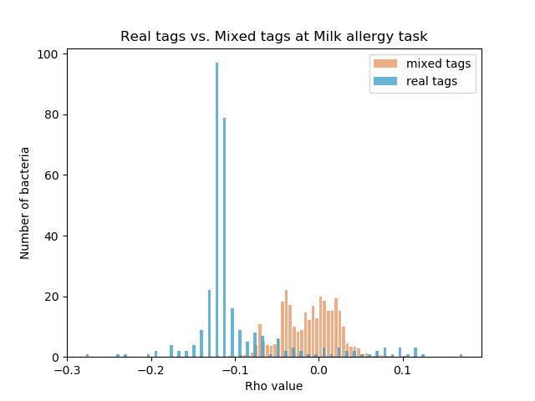

Significant bacteria –

|  |  |
| --- | --- |
| -0.27603 | k__Bacteria; p__Firmicutes; c__Erysipelotrichi; o__Erysipelotrichales; f__Erysipelotrichaceae; g__ |
| -0.23358 | k__Bacteria; p__Firmicutes; c__Bacilli; o__Lactobacillales; f__Streptococcaceae; g__Lactococcus |
| -0.22279 | k__Bacteria; p__Firmicutes; c__Clostridia; o__Clostridiales; f__Lachnospiraceae; g__Coprococcus |
| -0.19757 | k__Bacteria; p__Actinobacteria; c__Coriobacteriia; o__Coriobacteriales; f__Coriobacteriaceae; g__Eggerthella |
| -0.19364 | k__Bacteria; p__Firmicutes; c__Bacilli; o__Lactobacillales; f__Streptococcaceae; g__Streptococcus |
| -0.18721 | k__Bacteria; p__Firmicutes; c__Clostridia; o__Clostridiales; f__Lachnospiraceae; g__Blautia |
| -0.17483 | k__Bacteria; p__Firmicutes; c__Clostridia; o__Clostridiales; f__Lachnospiraceae; g__[Ruminococcus] |
| -0.17365 | k__Bacteria; p__Bacteroidetes; c__Bacteroidia; o__Bacteroidales; f__; g__ |
| -0.17227 | k__Bacteria; p__Firmicutes; c__Clostridia; o__Clostridiales; f__Lachnospiraceae; g__Dorea |
| -0.16849 | k__Bacteria; p__Bacteroidetes; c__Bacteroidia; o__Bacteroidales; f__[Paraprevotellaceae]; g__[Prevotella] |
| -0.16512 | k__Bacteria; p__Proteobacteria; c__Alphaproteobacteria; o__Rhizobiales; f__Bradyrhizobiaceae; g__Bradyrhizobium |
| -0.16298 | k__Bacteria; p__Firmicutes; c__Bacilli; o__Lactobacillales; f__Enterococcaceae; g__Enterococcus |
| -0.15755 | k__Bacteria; p__Firmicutes; c__Erysipelotrichi; o__Erysipelotrichales; f__Erysipelotrichaceae; g__Coprobacillus |
| -0.15675 | k__Bacteria; p__Cyanobacteria; c__4C0d-2; o__YS2; f__; g__ |
| -0.14504 | k__Bacteria; p__Synergistetes; c__Synergistia; o__Synergistales; f__Dethiosulfovibrionaceae; g__Pyramidobacter |
| -0.1445 | k__Bacteria; p__Firmicutes; c__Clostridia; o__Clostridiales; f__[Tissierellaceae]; g__Parvimonas |
| -0.14355 | k__Bacteria; p__Firmicutes; c__Clostridia; o__Clostridiales; f__Veillonellaceae; g__Megamonas |
| -0.14153 | k__Bacteria; p__Bacteroidetes |
| -0.13899 | k__Bacteria; p__Firmicutes; c__Bacilli; o__Lactobacillales; f__Leuconostocaceae; g__Leuconostoc |
| -0.13565 | k__Bacteria; p__Firmicutes; c__Clostridia; o__Clostridiales; f__[Tissierellaceae]; g__WAL_1855D |
| -0.13529 | k__Bacteria; p__Firmicutes; c__Erysipelotrichi; o__Erysipelotrichales; f__Erysipelotrichaceae; g__[Eubacterium] |
| -0.13475 | k__Bacteria; p__Proteobacteria; c__Alphaproteobacteria; o__RF32; f__; g__ |
| -0.13256 | k__Bacteria; p__Proteobacteria; c__Gammaproteobacteria; o__Pseudomonadales; f__Pseudomonadaceae; g__Pseudomonas |
| -0.13224 | k__Bacteria; p__Firmicutes; c__Clostridia; o__Clostridiales; f__Veillonellaceae; g__Succiniclasticum |
| -0.1309 | k__Bacteria; p__Actinobacteria; c__Actinobacteria; o__Actinomycetales; f__Actinomycetaceae; g__Varibaculum |
| -0.13081 | k__Bacteria; p__Firmicutes; c__Clostridia; o__Clostridiales; f__[Tissierellaceae]; g__ph2 |
| -0.13062 | k__Bacteria; p__Proteobacteria; c__Gammaproteobacteria; o__Pasteurellales; f__Pasteurellaceae; g__Aggregatibacter |
| -0.12865 | k__Bacteria; p__Firmicutes; c__Bacilli; o__Lactobacillales; f__Leuconostocaceae; g__ |
| -0.12865 | k__Bacteria; p__Firmicutes; c__Clostridia; o__Clostridiales; f__[Tissierellaceae]; g__1-68 |
| -0.12757 | k__Bacteria; p__Proteobacteria; c__Alphaproteobacteria; o__Rhodospirillales; f__Acetobacteraceae; g__Acetobacter |
| -0.12745 | k__Bacteria; p__Actinobacteria; c__Coriobacteriia; o__Coriobacteriales; f__Coriobacteriaceae; g__Atopobium |
| -0.12676 | k__Bacteria; p__Firmicutes; c__Clostridia; o__Clostridiales; f__Veillonellaceae; g__Phascolarctobacterium |
| -0.12664 | k__Bacteria; p__TM7; c__TM7-3; o__; f__; g__ |
| -0.12652 | k__Bacteria; p__Tenericutes; c__Mollicutes; o__Anaeroplasmatales; f__Anaeroplasmataceae; g__Anaeroplasma |
| -0.12645 | k__Bacteria; p__Firmicutes; c__Clostridia; o__Clostridiales; f__Ruminococcaceae; g__Anaerotruncus |
| -0.12632 | k__Bacteria; p__Fusobacteria; c__Fusobacteriia; o__Fusobacteriales; f__Leptotrichiaceae; g__Leptotrichia |
| -0.12617 | k__Bacteria; p__Deferribacteres; c__Deferribacteres; o__Deferribacterales; f__Deferribacteraceae; g__Mucispirillum |
| -0.12608 | k__Bacteria; p__Firmicutes; c__Clostridia; o__Clostridiales; f__Veillonellaceae; g__ |
| -0.12542 | k__Bacteria; p__Firmicutes; c__Clostridia; o__Clostridiales; f__Peptococcaceae; g__Peptococcus |
| -0.12419 | k__Bacteria; p__Proteobacteria; c__Gammaproteobacteria; o__Enterobacteriales; f__Enterobacteriaceae; g__Yersinia |
| -0.12377 | k__Bacteria; p__Firmicutes; c__Clostridia; o__Clostridiales; f__Dehalobacteriaceae; g__ |
| -0.1234 | k__Bacteria; p__Proteobacteria; c__Gammaproteobacteria; o__Cardiobacteriales; f__Cardiobacteriaceae; g__Cardiobacterium |
| -0.12302 | k__Bacteria; p__Firmicutes; c__Clostridia; o__Clostridiales; f__Eubacteriaceae; g__Anaerofustis |
| -0.12226 | k__Bacteria; p__Firmicutes; c__Bacilli; o__Turicibacterales; f__Turicibacteraceae; g__Turicibacter |
| -0.12224 | k__Bacteria; p__Firmicutes; c__Clostridia; o__Clostridiales; f__Lachnospiraceae; g__Moryella |
| -0.12195 | k__Bacteria; p__Proteobacteria; c__Betaproteobacteria; o__Burkholderiales; f__Comamonadaceae; g__Comamonas |
| -0.12173 | k__Bacteria; p__Synergistetes; c__Synergistia; o__Synergistales; f__Dethiosulfovibrionaceae; g__TG5 |
| -0.12166 | k__Bacteria; p__Firmicutes; c__Clostridia; o__Clostridiales; f__Lachnospiraceae; g__Epulopiscium |
| -0.12138 | k__Bacteria; p__Firmicutes; c__Erysipelotrichi; o__Erysipelotrichales; f__Erysipelotrichaceae; g__RFN20 |
| -0.12134 | k__Bacteria; p__Firmicutes; c__Clostridia; o__Clostridiales; f__Peptostreptococcaceae |
| -0.12066 | k__Bacteria; p__Firmicutes; c__Clostridia; o__Clostridiales; f__EtOH8; g__ |
| -0.11999 | k__Bacteria; p__Bacteroidetes; c__Bacteroidia; o__Bacteroidales; f__Rikenellaceae; g__Alistipes |
| -0.11995 | k__Bacteria; p__Proteobacteria; c__Epsilonproteobacteria; o__Campylobacterales; f__Helicobacteraceae |
| -0.11994 | k__Bacteria; p__Firmicutes; c__Clostridia; o__Clostridiales; f__[Tissierellaceae]; g__Gallicola |
| -0.11965 | k__Bacteria; p__Proteobacteria; c__Gammaproteobacteria; o__Xanthomonadales; f__Xanthomonadaceae; g__Pseudoxanthomonas |
| -0.11959 | k__Bacteria; p__Verrucomicrobia; c__Opitutae; o__HA64; f__; g__ |
| -0.11943 | k__Bacteria; p__Proteobacteria; c__Alphaproteobacteria; o__Rhizobiales; f__Methylobacteriaceae; g__ |
| -0.11941 | k__Bacteria; p__Proteobacteria; c__Epsilonproteobacteria; o__Campylobacterales; f__Helicobacteraceae; g__Helicobacter |
| -0.11888 | k__Bacteria; p__Bacteroidetes; c__[Saprospirae]; o__[Saprospirales]; f__Chitinophagaceae; g__ |
| -0.11854 | k__Bacteria; p__Fusobacteria; c__Fusobacteriia; o__Fusobacteriales; f__Fusobacteriaceae; g__Fusobacterium |
| -0.11822 | k__Bacteria; p__Proteobacteria; c__Betaproteobacteria; o__Burkholderiales; f__Burkholderiaceae; g__Lautropia |
| -0.11807 | k__Bacteria; p__Lentisphaerae; c__[Lentisphaeria]; o__Victivallales; f__Victivallaceae; g__ |
| -0.11782 | k__Bacteria; p__Proteobacteria; c__Alphaproteobacteria; o__Rhizobiales; f__; g__ |
| -0.11774 | k__Bacteria; p__Actinobacteria; c__Actinobacteria; o__Actinomycetales; f__Actinomycetaceae; g__Mobiluncus |
| -0.11765 | k__Bacteria; p__Firmicutes; c__Clostridia; o__Clostridiales; f__[Tissierellaceae]; g__Finegoldia |
| -0.1175 | k__Bacteria; p__Proteobacteria; c__Gammaproteobacteria; o__Aeromonadales; f__Succinivibrionaceae; g__ |
| -0.11711 | k__Bacteria; p__Firmicutes; c__Erysipelotrichi; o__Erysipelotrichales; f__Erysipelotrichaceae; g__Allobaculum |
| -0.11711 | k__Bacteria; p__Proteobacteria; c__Gammaproteobacteria; o__Enterobacteriales; f__Enterobacteriaceae; g__Erwinia |
| -0.11708 | k__Bacteria; p__Firmicutes; c__Bacilli; o__Bacillales; f__Paenibacillaceae; g__Paenibacillus |
| -0.11708 | k__Bacteria; p__TM7; c__TM7-3; o__CW040; f__F16; g__ |
| -0.11705 | k__Bacteria; p__Firmicutes; c__Clostridia; o__Clostridiales; f__Clostridiaceae; g__02d06 |
| -0.11674 | k__Bacteria; p__Bacteroidetes; c__Bacteroidia; o__Bacteroidales; f__[Paraprevotellaceae]; g__YRC22 |
| -0.11666 | k__Bacteria; p__Firmicutes; c__Clostridia; o__Clostridiales; f__Veillonellaceae; g__Schwartzia |
| -0.11664 | k__Bacteria; p__Bacteroidetes; c__Flavobacteriia; o__Flavobacteriales; f__[Weeksellaceae]; g__ |
| -0.11652 | k__Bacteria; p__Proteobacteria; c__Deltaproteobacteria; o__Bdellovibrionales; f__Bdellovibrionaceae; g__Bdellovibrio |
| -0.11607 | k__Bacteria; p__Proteobacteria; c__Alphaproteobacteria; o__Rhizobiales; f__Hyphomicrobiaceae; g__ |
| -0.11599 | k__Bacteria; p__Firmicutes; c__Clostridia; o__Clostridiales; f__Veillonellaceae; g__Selenomonas |
| -0.11552 | k__Bacteria; p__Proteobacteria; c__Betaproteobacteria; o__Neisseriales; f__Neisseriaceae |
| -0.11545 | k__Bacteria; p__Proteobacteria; c__Epsilonproteobacteria; o__Campylobacterales; f__Campylobacteraceae; g__Campylobacter |
| -0.11543 | k__Bacteria; p__Proteobacteria; c__Gammaproteobacteria; o__Enterobacteriales; f__Enterobacteriaceae; g__Providencia |
| -0.11534 | k__Bacteria; p__Proteobacteria; c__Betaproteobacteria; o__Burkholderiales; f__Alcaligenaceae; g__Alcaligenes |
| -0.11523 | k__Bacteria; p__Firmicutes; c__Bacilli; o__Gemellales; f__Gemellaceae; g__Gemella |
| -0.11518 | k__Bacteria; p__Proteobacteria; c__Gammaproteobacteria; o__Pseudomonadales; f__Moraxellaceae; g__Enhydrobacter |
| -0.11479 | k__Bacteria; p__Proteobacteria; c__Gammaproteobacteria; o__Enterobacteriales; f__Enterobacteriaceae; g__Shigella |
| -0.11458 | k__Bacteria; p__Actinobacteria; c__Actinobacteria; o__Bifidobacteriales; f__Bifidobacteriaceae; g__Alloscardovia |
| -0.11453 | k__Bacteria; p__Firmicutes; c__Clostridia; o__Clostridiales; f__Lachnospiraceae; g__Oribacterium |
| -0.1145 | k__Bacteria; p__Bacteroidetes; c__Bacteroidia; o__Bacteroidales; f__Porphyromonadaceae; g__Porphyromonas |
| -0.11442 | k__Bacteria; p__Firmicutes; c__Clostridia; o__Clostridiales; f__Peptostreptococcaceae; g__[Clostridium] |
| -0.1143 | k__Bacteria; p__Actinobacteria; c__Coriobacteriia; o__Coriobacteriales; f__Coriobacteriaceae; g__Collinsella |
| -0.11423 | k__Bacteria; p__Actinobacteria; c__Actinobacteria; o__Actinomycetales; f__Microbacteriaceae |
| -0.11423 | k__Bacteria; p__Lentisphaerae; c__[Lentisphaeria]; o__Victivallales; f__Victivallaceae; g__Victivallis |
| -0.11423 | k__Bacteria; p__Proteobacteria; c__Alphaproteobacteria; o__Rickettsiales; f__Rickettsiaceae; g__Wolbachia |
| -0.11422 | k__Bacteria; p__Cyanobacteria; c__ML635J-21; o__; f__; g__ |
| -0.11422 | k__Bacteria; p__Firmicutes; c__Bacilli |
| -0.11422 | k__Bacteria; p__Proteobacteria; c__Alphaproteobacteria; o__Rhodobacterales; f__Rhodobacteraceae; g__Amaricoccus |
| -0.11422 | k__Bacteria; p__Proteobacteria; c__Alphaproteobacteria; o__Sphingomonadales; f__Sphingomonadaceae; g__Sphingopyxis |
| -0.11422 | k__Bacteria; p__Proteobacteria; c__Epsilonproteobacteria; o__Campylobacterales; f__Helicobacteraceae; g__Flexispira |
| -0.11422 | k__Bacteria; p__Proteobacteria; c__Gammaproteobacteria; o__Enterobacteriales; f__Enterobacteriaceae; g__Sodalis |
| -0.11422 | k__Bacteria; p__Verrucomicrobia; c__Verrucomicrobiae; o__Verrucomicrobiales; f__Verrucomicrobiaceae; g__Prosthecobacter |
| -0.11419 | k__Bacteria; p__Actinobacteria; c__Thermoleophilia; o__Solirubrobacterales; f__Conexibacteraceae; g__ |
| -0.11419 | k__Bacteria; p__Proteobacteria; c__Alphaproteobacteria; o__Caulobacterales; f__Caulobacteraceae; g__Mycoplana |
| -0.11411 | k__Bacteria; p__Bacteroidetes; c__[Saprospirae]; o__[Saprospirales]; f__Chitinophagaceae; g__Sediminibacterium |
| -0.11411 | k__Bacteria; p__Proteobacteria; c__Gammaproteobacteria; o__Pasteurellales; f__Pasteurellaceae |
| -0.11409 | k__Bacteria; p__Proteobacteria; c__Betaproteobacteria; o__Rhodocyclales; f__Rhodocyclaceae; g__Dok59 |
| -0.11405 | k__Bacteria; p__Firmicutes; c__Clostridia; o__Clostridiales; f__[Mogibacteriaceae]; g__Anaerovorax |
| -0.114 | k__Bacteria; p__Chloroflexi; c__Anaerolineae; o__SBR1031; f__A4b; g__ |
| -0.114 | k__Bacteria; p__Proteobacteria; c__Alphaproteobacteria; o__Rhizobiales; f__Phyllobacteriaceae; g__ |
| -0.114 | k__Bacteria; p__Proteobacteria; c__Betaproteobacteria; o__Burkholderiales; f__Comamonadaceae; g__Methylibium |
| -0.114 | k__Bacteria; p__Proteobacteria; c__Deltaproteobacteria; o__Myxococcales; f__; g__ |
| -0.11397 | k__Bacteria; p__Proteobacteria; c__Alphaproteobacteria; o__Rhodobacterales; f__Rhodobacteraceae |
| -0.11395 | k__Bacteria; p__Bacteroidetes; c__Flavobacteriia; o__Flavobacteriales; f__Flavobacteriaceae; g__Flavobacterium |
| -0.11395 | k__Bacteria; p__Bacteroidetes; c__Flavobacteriia; o__Flavobacteriales; f__[Weeksellaceae]; g__Chryseobacterium |
| -0.11395 | k__Bacteria; p__Proteobacteria; c__Alphaproteobacteria; o__BD7-3; f__; g__ |
| -0.11395 | k__Bacteria; p__Proteobacteria; c__Alphaproteobacteria; o__Caulobacterales; f__Caulobacteraceae; g__ |
| -0.11395 | k__Bacteria; p__Proteobacteria; c__Alphaproteobacteria; o__Rhizobiales; f__Rhizobiaceae; g__Rhizobium |
| -0.11395 | k__Bacteria; p__Proteobacteria; c__Alphaproteobacteria; o__Rhodospirillales; f__Acetobacteraceae; g__ |
| -0.11395 | k__Bacteria; p__Proteobacteria; c__Alphaproteobacteria; o__Sphingomonadales; f__; g__ |
| -0.11395 | k__Bacteria; p__Proteobacteria; c__Alphaproteobacteria; o__Sphingomonadales; f__Sphingomonadaceae; g__ |
| -0.11395 | k__Bacteria; p__Proteobacteria; c__Alphaproteobacteria; o__Sphingomonadales; f__Sphingomonadaceae; g__Novosphingobium |
| -0.11395 | k__Bacteria; p__Proteobacteria; c__Alphaproteobacteria; o__Sphingomonadales; f__Sphingomonadaceae; g__Sphingobium |
| -0.11392 | k__Bacteria; p__Chloroflexi; c__Anaerolineae; o__GCA004; f__; g__ |
| -0.1139 | k__Bacteria; p__Proteobacteria; c__Alphaproteobacteria; o__Rhizobiales; f__Brucellaceae |
| -0.11383 | k__Bacteria; p__Chloroflexi; c__Thermomicrobia; o__AKYG1722; f__; g__ |
| -0.11383 | k__Bacteria; p__Firmicutes; c__Erysipelotrichi; o__Erysipelotrichales; f__Erysipelotrichaceae; g__Clostridium |
| -0.11343 | k__Bacteria; p__Proteobacteria; c__Betaproteobacteria; o__Burkholderiales; f__Alcaligenaceae; g__Achromobacter |
| -0.11335 | k__Bacteria; p__Actinobacteria |
| -0.11329 | k__Bacteria; p__Proteobacteria; c__Gammaproteobacteria; o__Enterobacteriales; f__Enterobacteriaceae; g__Trabulsiella |
| -0.11322 | k__Bacteria; p__Proteobacteria; c__Gammaproteobacteria; o__Enterobacteriales; f__Enterobacteriaceae; g__Serratia |
| -0.11309 | k__Bacteria; p__Proteobacteria; c__Betaproteobacteria; o__Burkholderiales; f__Comamonadaceae |
| -0.11307 | k__Bacteria; p__Firmicutes; c__Clostridia; o__Clostridiales; f__[Tissierellaceae]; g__Peptoniphilus |
| -0.11296 | k__Bacteria; p__Actinobacteria; c__Actinobacteria; o__Actinomycetales; f__Nocardiaceae; g__Rhodococcus |
| -0.11296 | k__Bacteria; p__Proteobacteria; c__Betaproteobacteria; o__Burkholderiales; f__Oxalobacteraceae; g__Janthinobacterium |
| -0.11292 | k__Bacteria; p__Actinobacteria; c__Actinobacteria; o__Actinomycetales; f__Pseudonocardiaceae |
| -0.11291 | k__Bacteria; p__Firmicutes; c__Clostridia; o__Clostridiales; f__Clostridiaceae |
| -0.11281 | k__Bacteria; p__Proteobacteria; c__Betaproteobacteria; o__Neisseriales; f__Neisseriaceae; g__ |
| -0.11269 | k__Bacteria; p__Firmicutes; c__Bacilli; o__Lactobacillales; f__Leuconostocaceae; g__Weissella |
| -0.11269 | k__Bacteria; p__Fusobacteria; c__Fusobacteriia; o__Fusobacteriales; f__Leptotrichiaceae; g__ |
| -0.11257 | k__Bacteria; p__Proteobacteria; c__Alphaproteobacteria; o__Rhodospirillales; f__Acetobacteraceae; g__Gluconobacter |
| -0.11251 | k__Bacteria; p__Fusobacteria; c__Fusobacteriia; o__Fusobacteriales; f__Fusobacteriaceae; g__Cetobacterium |
| -0.1125 | k__Bacteria; p__Proteobacteria; c__Betaproteobacteria; o__Burkholderiales; f__Oxalobacteraceae |
| -0.11248 | k__Bacteria; p__Actinobacteria; c__Actinobacteria; o__Actinomycetales; f__Microbacteriaceae; g__Leucobacter |
| -0.11242 | k__Bacteria; p__Proteobacteria; c__Alphaproteobacteria; o__Rhizobiales; f__Brucellaceae; g__Ochrobactrum |
| -0.11242 | k__Bacteria; p__Proteobacteria; c__Betaproteobacteria; o__Burkholderiales; f__Comamonadaceae; g__Delftia |
| -0.11236 | k__Bacteria; p__Proteobacteria; c__Alphaproteobacteria; o__Rhizobiales; f__Rhizobiaceae; g__Agrobacterium |
| -0.1123 | k__Bacteria; p__Proteobacteria; c__Alphaproteobacteria; o__Rhizobiales; f__Hyphomicrobiaceae; g__Devosia |
| -0.1123 | k__Bacteria; p__[Thermi]; c__Deinococci; o__Thermales; f__Thermaceae; g__Thermus |
| -0.11223 | k__Bacteria; p__Proteobacteria; c__Alphaproteobacteria; o__Rhizobiales; f__Rhizobiaceae; g__Shinella |
| -0.11218 | k__Bacteria; p__Bacteroidetes; c__Bacteroidia; o__Bacteroidales; f__Prevotellaceae |
| -0.11218 | k__Bacteria; p__[Thermi]; c__Deinococci; o__Deinococcales; f__Deinococcaceae; g__R18-435 |
| -0.11213 | k__Bacteria; p__Firmicutes; c__Bacilli; o__Bacillales; f__Staphylococcaceae; g__Jeotgalicoccus |
| -0.11213 | k__Bacteria; p__Firmicutes; c__Clostridia; o__Clostridiales; f__Veillonellaceae |
| -0.11208 | k__Bacteria; p__Proteobacteria; c__Betaproteobacteria; o__Neisseriales; f__Neisseriaceae; g__Eikenella |
| -0.11204 | k__Bacteria; p__Proteobacteria; c__Betaproteobacteria; o__Burkholderiales; f__Burkholderiaceae; g__Burkholderia |
| -0.11186 | k__Bacteria; p__Firmicutes; c__Clostridia; o__Clostridiales; f__Lachnospiraceae; g__Butyrivibrio |
| -0.11183 | k__Bacteria; p__Proteobacteria; c__Gammaproteobacteria; o__Enterobacteriales; f__Enterobacteriaceae; g__Proteus |
| -0.11173 | k__Bacteria; p__Proteobacteria; c__Gammaproteobacteria; o__Enterobacteriales; f__Enterobacteriaceae; g__Plesiomonas |
| -0.11172 | k__Bacteria; p__Proteobacteria |
| -0.11167 | k__Bacteria; p__Acidobacteria; c__Acidobacteria-6; o__iii1-15; f__mb2424; g__ |
| -0.11166 | k__Bacteria; p__Proteobacteria; c__Alphaproteobacteria; o__Rhodobacterales; f__Rhodobacteraceae; g__Paracoccus |
| -0.11147 | k__Bacteria; p__Bacteroidetes; c__Bacteroidia; o__Bacteroidales; f__Porphyromonadaceae |
| -0.11146 | k__Bacteria; p__Bacteroidetes; c__Bacteroidia; o__Bacteroidales; f__Rikenellaceae; g__AF12 |
| -0.11146 | k__Bacteria; p__Firmicutes; c__Clostridia; o__Clostridiales; f__[Tissierellaceae]; g__ |
| -0.11135 | k__Bacteria; p__Actinobacteria; c__Actinobacteria; o__Actinomycetales; f__Dermabacteraceae; g__Dermabacter |
| -0.11135 | k__Bacteria; p__Actinobacteria; c__Actinobacteria; o__Actinomycetales; f__Micrococcaceae |
| -0.11135 | k__Bacteria; p__Bacteroidetes; c__Bacteroidia; o__Bacteroidales; f__[Paraprevotellaceae]; g__CF231 |
| -0.11135 | k__Bacteria; p__Bacteroidetes; c__Sphingobacteriia; o__Sphingobacteriales; f__Sphingobacteriaceae; g__Pedobacter |
| -0.11135 | k__Bacteria; p__Firmicutes; c__Bacilli; o__Bacillales; f__Bacillaceae; g__Geobacillus |
| -0.11135 | k__Bacteria; p__Firmicutes; c__Clostridia; o__Clostridiales; f__Ruminococcaceae; g__Ethanoligenens |
| -0.11135 | k__Bacteria; p__Firmicutes; c__Clostridia; o__Clostridiales; f__[Acidaminobacteraceae]; g__ |
| -0.11135 | k__Bacteria; p__Fusobacteria; c__Fusobacteriia; o__Fusobacteriales; f__Leptotrichiaceae; g__Sneathia |
| -0.11135 | k__Bacteria; p__Proteobacteria; c__Alphaproteobacteria; o__Caulobacterales; f__Caulobacteraceae; g__Brevundimonas |
| -0.11135 | k__Bacteria; p__Proteobacteria; c__Alphaproteobacteria; o__Rhizobiales |
| -0.11135 | k__Bacteria; p__Proteobacteria; c__Alphaproteobacteria; o__Rhizobiales; f__Bradyrhizobiaceae; g__Balneimonas |
| -0.11135 | k__Bacteria; p__Proteobacteria; c__Alphaproteobacteria; o__Rhodobacterales; f__Rhodobacteraceae; g__Rhodobacter |
| -0.11135 | k__Bacteria; p__Proteobacteria; c__Alphaproteobacteria; o__Sphingomonadales; f__Sphingomonadaceae |
| -0.11135 | k__Bacteria; p__Proteobacteria; c__Gammaproteobacteria; o__Aeromonadales; f__Succinivibrionaceae |
| -0.11135 | k__Bacteria; p__WPS-2; c__; o__; f__; g__ |
| -0.11114 | k__Bacteria; p__Firmicutes; c__Bacilli; o__Bacillales; f__Bacillaceae |
| -0.11107 | k__Bacteria; p__Verrucomicrobia; c__Opitutae; o__[Cerasicoccales]; f__[Cerasicoccaceae]; g__ |
| -0.11071 | k__Bacteria; p__Tenericutes; c__Mollicutes; o__Mycoplasmatales; f__Mycoplasmataceae; g__Mycoplasma |
| -0.11062 | k__Bacteria; p__Bacteroidetes; c__Bacteroidia; o__Bacteroidales; f__Porphyromonadaceae; g__Dysgonomonas |
| -0.11061 | k__Bacteria; p__Bacteroidetes; c__Cytophagia; o__Cytophagales; f__Cytophagaceae; g__Leadbetterella |
| -0.1106 | k__Bacteria; p__Firmicutes; c__Bacilli; o__Lactobacillales; f__Aerococcaceae; g__Facklamia |
| -0.11059 | k__Bacteria; p__Firmicutes; c__Erysipelotrichi; o__Erysipelotrichales; f__Erysipelotrichaceae; g__Bulleidia |
| -0.11042 | k__Bacteria; p__Firmicutes |
| -0.11029 | k__Bacteria; p__Firmicutes; c__Clostridia; o__Clostridiales; f__Ruminococcaceae; g__Clostridium |
| -0.1102 | k__Bacteria; p__Actinobacteria; c__Actinobacteria; o__Bifidobacteriales; f__Bifidobacteriaceae; g__Scardovia |
| -0.11 | k__Bacteria; p__Tenericutes; c__Mollicutes; o__Anaeroplasmatales; f__Anaeroplasmataceae; g__ |
| -0.10985 | k__Bacteria; p__Firmicutes; c__Bacilli; o__Lactobacillales |
| -0.10978 | k__Bacteria; p__Proteobacteria; c__Gammaproteobacteria; o__Pseudomonadales; f__Moraxellaceae; g__Acinetobacter |
| -0.10959 | k__Bacteria; p__Firmicutes; c__Clostridia; o__Clostridiales; f__Christensenellaceae |
| -0.10933 | k__Bacteria; p__Firmicutes; c__Clostridia; o__Clostridiales; f__Lachnospiraceae; g__Catonella |
| -0.10873 | k__Bacteria; p__Bacteroidetes; c__Flavobacteriia; o__Flavobacteriales; f__[Weeksellaceae]; g__Wautersiella |
| -0.10872 | k__Bacteria; p__Proteobacteria; c__Gammaproteobacteria; o__Enterobacteriales; f__Enterobacteriaceae; g__Enterobacter |
| -0.10795 | k__Bacteria; p__Firmicutes; c__Bacilli; o__Lactobacillales; f__Lactobacillaceae |
| -0.10793 | k__Bacteria; p__Firmicutes; c__Clostridia; o__Clostridiales; f__Ruminococcaceae; g__Gemmiger |
| -0.10775 | k__Bacteria; p__Actinobacteria; c__Actinobacteria; o__Actinomycetales; f__Intrasporangiaceae |
| -0.10751 | k__Bacteria; p__Firmicutes; c__Clostridia; o__Clostridiales; f__Ruminococcaceae; g__Sporobacter |
| -0.10746 | k__Bacteria; p__Firmicutes; c__Clostridia; o__Clostridiales; f__Ruminococcaceae; g__Butyricicoccus |
| -0.10744 | k__Bacteria; p__Firmicutes; c__Bacilli; o__Bacillales |
| -0.10741 | k__Bacteria; p__Proteobacteria; c__Betaproteobacteria; o__Neisseriales; f__Neisseriaceae; g__Kingella |
| -0.10731 | k__Bacteria; p__Firmicutes; c__Bacilli; o__Gemellales; f__Gemellaceae; g__ |
| -0.10701 | k__Bacteria; p__Proteobacteria; c__Gammaproteobacteria; o__Xanthomonadales; f__Xanthomonadaceae; g__Stenotrophomonas |
| -0.10692 | k__Bacteria; p__Proteobacteria; c__Alphaproteobacteria; o__Rhizobiales; f__Rhizobiaceae; g__ |
| -0.10692 | k__Bacteria; p__Proteobacteria; c__Betaproteobacteria; o__Burkholderiales; f__Oxalobacteraceae; g__Cupriavidus |
| -0.10687 | k__Bacteria; p__Cyanobacteria; c__Oscillatoriophycideae; o__Oscillatoriales; f__Phormidiaceae; g__Phormidium |
| -0.10672 | k__Bacteria; p__Proteobacteria; c__Betaproteobacteria; o__Rhodocyclales; f__Rhodocyclaceae; g__Thauera |
| -0.10665 | k__Bacteria; p__Firmicutes; c__Clostridia; o__Clostridiales; f__Lachnospiraceae; g__Pseudobutyrivibrio |
| -0.10662 | k__Bacteria; p__Firmicutes; c__Erysipelotrichi; o__Erysipelotrichales; f__Erysipelotrichaceae |
| -0.10651 | k__Bacteria; p__Proteobacteria; c__Betaproteobacteria; o__Burkholderiales; f__Burkholderiaceae |
| -0.10638 | k__Bacteria; p__Actinobacteria; c__Actinobacteria; o__Bifidobacteriales; f__Bifidobacteriaceae |
| -0.10638 | k__Bacteria; p__Proteobacteria; c__Betaproteobacteria; o__Burkholderiales; f__Alcaligenaceae; g__ |
| -0.10638 | k__Bacteria; p__Proteobacteria; c__Gammaproteobacteria; o__Enterobacteriales; f__Enterobacteriaceae; g__Citrobacter |
| -0.1061 | k__Bacteria; p__Proteobacteria; c__Alphaproteobacteria; o__Caulobacterales; f__Caulobacteraceae |
| -0.10562 | k__Bacteria; p__Firmicutes; c__Clostridia; o__Clostridiales; f__Peptococcaceae; g__rc4-4 |
| -0.1055 | k__Archaea |
| -0.10539 | k__Bacteria; p__Proteobacteria; c__Gammaproteobacteria; o__Pseudomonadales; f__Pseudomonadaceae |
| -0.10535 | k__Bacteria; p__Bacteroidetes; c__Flavobacteriia; o__Flavobacteriales; f__Flavobacteriaceae; g__Capnocytophaga |
| -0.10526 | k__Bacteria; p__Bacteroidetes; c__Bacteroidia; o__Bacteroidales; f__Porphyromonadaceae; g__Paludibacter |
| -0.10521 | k__Bacteria; p__Actinobacteria; c__Coriobacteriia; o__Coriobacteriales; f__Coriobacteriaceae; g__Adlercreutzia |
| -0.10512 | k__Bacteria; p__Firmicutes; c__Bacilli; o__Lactobacillales; f__Aerococcaceae; g__Alloiococcus |
| -0.10489 | k__Bacteria; p__Firmicutes; c__Bacilli; o__Lactobacillales; f__Carnobacteriaceae; g__Trichococcus |
| -0.10489 | k__Bacteria; p__SR1; c__; o__; f__; g__ |
| -0.10466 | k__Bacteria; p__Bacteroidetes; c__Bacteroidia; o__Bacteroidales; f__Rikenellaceae |
| -0.1034 | k__Bacteria; p__Firmicutes; c__Bacilli; o__Bacillales; f__Staphylococcaceae; g__Staphylococcus |
| -0.10305 | k__Bacteria; p__Actinobacteria; c__Coriobacteriia; o__Coriobacteriales; f__Coriobacteriaceae |
| -0.10291 | k__Bacteria; p__Firmicutes; c__Clostridia; o__Clostridiales; f__Peptostreptococcaceae; g__Peptostreptococcus |
| -0.10211 | k__Bacteria; p__Bacteroidetes; c__Bacteroidia; o__Bacteroidales; f__Rikenellaceae; g__Rikenella |
| -0.1015 | k__Bacteria; p__Bacteroidetes; c__Sphingobacteriia; o__Sphingobacteriales; f__Sphingobacteriaceae; g__Sphingobacterium |
| -0.10144 | k__Bacteria; p__Synergistetes; c__Synergistia; o__Synergistales; f__Synergistaceae; g__ |
| -0.09982 | k__Bacteria; p__Spirochaetes; c__Spirochaetes; o__Spirochaetales; f__Spirochaetaceae; g__Treponema |
| -0.09963 | k__Bacteria; p__Synergistetes; c__Synergistia; o__Synergistales; f__Synergistaceae; g__Synergistes |
| -0.09867 | k__Bacteria; p__Firmicutes; c__Clostridia; o__Clostridiales; f__[Mogibacteriaceae]; g__Mogibacterium |
| -0.09798 | k__Bacteria; p__Firmicutes; c__Erysipelotrichi; o__Erysipelotrichales; f__Erysipelotrichaceae; g__cc_115 |
| -0.09715 | k__Bacteria; p__Verrucomicrobia; c__Verrucomicrobiae; o__Verrucomicrobiales; f__Verrucomicrobiaceae; g__Akkermansia |
| -0.09651 | k__Bacteria; p__Firmicutes; c__Bacilli; o__Lactobacillales; f__Aerococcaceae; g__Abiotrophia |
| -0.0963 | k__Bacteria; p__Firmicutes; c__Bacilli; o__Bacillales; f__Bacillaceae; g__Bacillus |
| -0.09604 | k__Bacteria; p__Firmicutes; c__Erysipelotrichi; o__Erysipelotrichales; f__Erysipelotrichaceae; g__Holdemania |
| -0.09585 | k__Bacteria; p__Proteobacteria; c__Gammaproteobacteria; o__Pasteurellales; f__Pasteurellaceae; g__Actinobacillus |
| -0.0957 | k__Bacteria; p__Firmicutes; c__Clostridia; o__Clostridiales; f__Eubacteriaceae; g__Pseudoramibacter_Eubacterium |
| -0.09479 | k__Bacteria; p__Proteobacteria; c__Betaproteobacteria; o__Burkholderiales |
| -0.0939 | k__Bacteria; p__Proteobacteria; c__Deltaproteobacteria; o__Desulfovibrionales; f__Desulfovibrionaceae; g__Desulfovibrio |
| -0.09299 | k__Bacteria; p__Firmicutes; c__Clostridia; o__Clostridiales; f__Lachnospiraceae; g__Clostridium |
| -0.09261 | k__Bacteria; p__Bacteroidetes; c__Bacteroidia; o__Bacteroidales; f__S24-7; g__ |
| -0.09152 | k__Bacteria; p__Bacteroidetes; c__Bacteroidia; o__Bacteroidales |
| -0.0897 | k__Archaea; p__Euryarchaeota; c__Methanobacteria; o__Methanobacteriales; f__Methanobacteriaceae; g__Methanosphaera |
| -0.08967 | k__Bacteria; p__Actinobacteria; c__Actinobacteria; o__Actinomycetales; f__Corynebacteriaceae; g__Corynebacterium |
| -0.08835 | k__Bacteria; p__Firmicutes; c__Clostridia |
| -0.08729 | k__Bacteria; p__Firmicutes; c__Clostridia; o__Clostridiales; f__Clostridiaceae; g__SMB53 |
| -0.08655 | k__Bacteria; p__Firmicutes; c__Clostridia; o__SHA-98; f__; g__ |
| -0.08314 | k__Bacteria; p__Proteobacteria; c__Gammaproteobacteria; o__Aeromonadales; f__Succinivibrionaceae; g__Succinivibrio |
| -0.08128 | k__Bacteria; p__Bacteroidetes; c__Bacteroidia; o__Bacteroidales; f__[Paraprevotellaceae]; g__ |
| -0.08016 | k__Bacteria; p__Firmicutes; c__Bacilli; o__Lactobacillales; f__Carnobacteriaceae; g__Granulicatella |
| -0.07757 | k__Bacteria; p__Firmicutes; c__Clostridia; o__Clostridiales; f__Lachnospiraceae; g__ |
| -0.07685 | k__Bacteria; p__Firmicutes; c__Clostridia; o__Clostridiales; f__[Mogibacteriaceae]; g__ |
| 0.062278 | k__Bacteria; p__Bacteroidetes; c__Bacteroidia; o__Bacteroidales; f__Bacteroidaceae; g__Bacteroides |
| 0.072036 | k__Bacteria; p__Proteobacteria; c__Deltaproteobacteria; o__Desulfovibrionales; f__Desulfovibrionaceae; g__Bilophila |
| 0.078518 | k__Bacteria; p__Firmicutes; c__Clostridia; o__Clostridiales; f__; g__ |
| 0.081113 | k__Bacteria; p__Firmicutes; c__Clostridia; o__Clostridiales; f__Ruminococcaceae |
| 0.084636 | k__Bacteria; p__Firmicutes; c__Clostridia; o__Clostridiales; f__Lachnospiraceae; g__Lachnospira |
| 0.086315 | k__Bacteria; p__Tenericutes; c__Mollicutes; o__RF39; f__; g__ |
| 0.093666 | k__Bacteria; p__Firmicutes; c__Clostridia; o__Clostridiales; f__Ruminococcaceae; g__Faecalibacterium |
| 0.101487 | k__Bacteria; p__Bacteroidetes; c__Bacteroidia; o__Bacteroidales; f__Prevotellaceae; g__Prevotella |
| 0.103119 | k__Bacteria; p__Bacteroidetes; c__Bacteroidia; o__Bacteroidales; f__[Barnesiellaceae]; g__ |
| 0.104904 | k__Bacteria; p__Firmicutes; c__Clostridia; o__Clostridiales |
| 0.110764 | k__Bacteria; p__Firmicutes; c__Clostridia; o__Clostridiales; f__Ruminococcaceae; g__ |
| 0.11963 | k__Bacteria; p__Bacteroidetes; c__Bacteroidia; o__Bacteroidales; f__Rikenellaceae; g__ |
| 0.122272 | k__Bacteria; p__Bacteroidetes; c__Bacteroidia; o__Bacteroidales; f__Porphyromonadaceae; g__Parabacteroides |
| 0.123857 | k__Bacteria; p__Firmicutes; c__Clostridia; o__Clostridiales; f__Christensenellaceae; g__ |
| 0.133392 | k__Bacteria; p__Proteobacteria; c__Betaproteobacteria; o__Burkholderiales; f__Oxalobacteraceae; g__Oxalobacter |
| 0.178884 | k__Bacteria; p__Firmicutes; c__Clostridia; o__Clostridiales; f__Veillonellaceae; g__Dialister |

Significant bacteria –

Too many to plot.

~~SVM~~

XGBOOST

Using anna preprocess didn’t improve the results.

The best parameters found by grid search are:

AUC

**train_auc: 0.9470720720720721**

**test_auc: 0.6793987865416437**

**train_rho: 0.8614679070342778**

**test_rho: 0.3460306968916471**

|  |  |  |
| --- | --- | --- |
|  | train accuracy | test accuracy |
| 0 | 0.935938 | 0.68125 |
| 1 | 0.923438 | 0.6875 |
| 2 | 0.923438 | 0.6875 |
| 3 | 0.948438 | 0.7625 |
| 4 | 0.942188 | 0.71875 |
| 5 | 0.934375 | 0.75 |
| 6 | 0.9375 | 0.7 |
| 7 | 0.935938 | 0.7 |
| 8 | 0.945313 | 0.68125 |
| 9 | 0.935938 | 0.725 |
| average | 0.93625 | 0.709375 |
| AUC | **0.947072** | **0.6793987** |

Confusion matrix

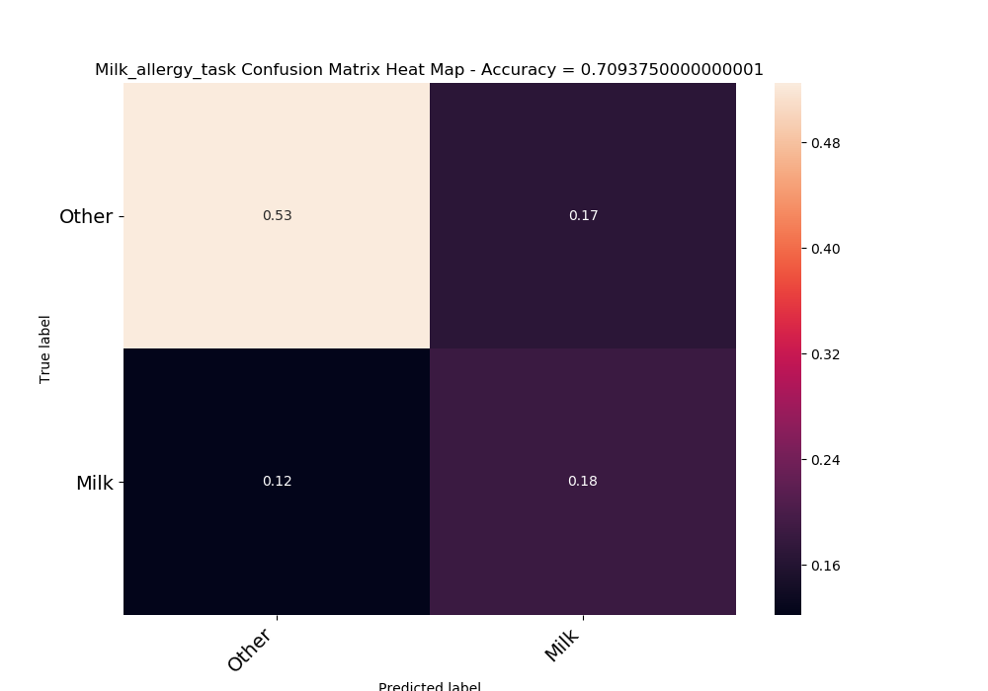

|  |  |  |
| --- | --- | --- |
|  | No | Yes |
| No | 0.525 | 0.16875 |
| Yes | 0.121875 | 0.184375 |
| acc | 0.709375 |  |

NN

Using Anna preprocess- 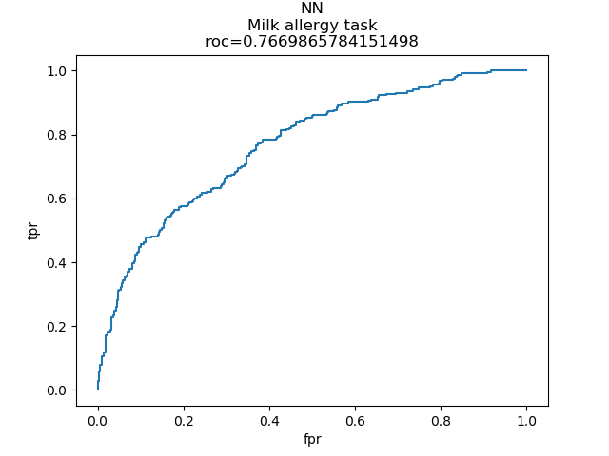

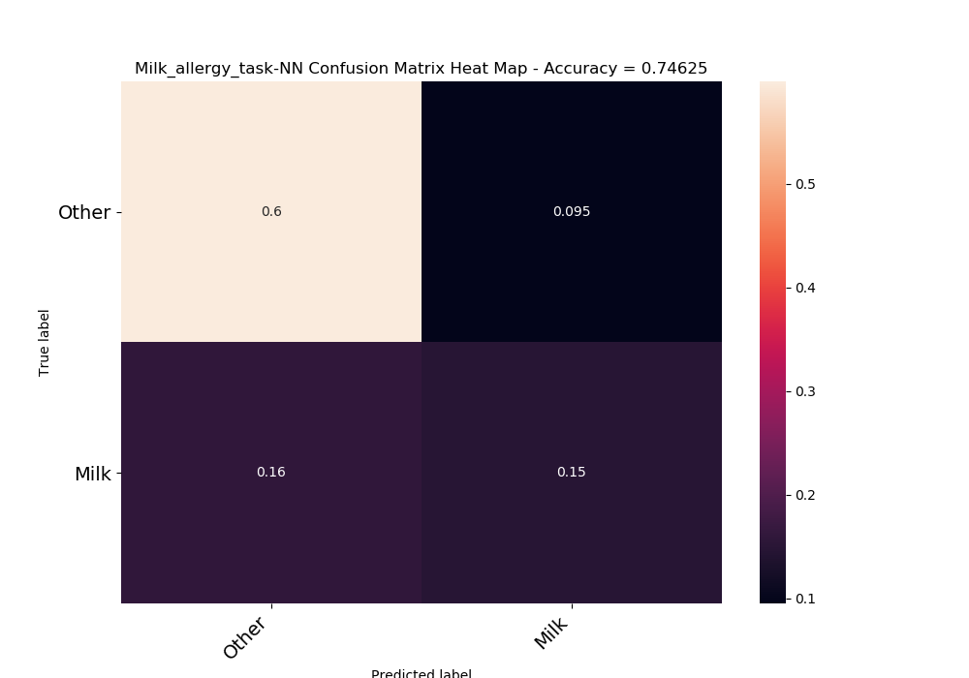

## Distinction between all types of allergies

Is patient allergic to milk or not?

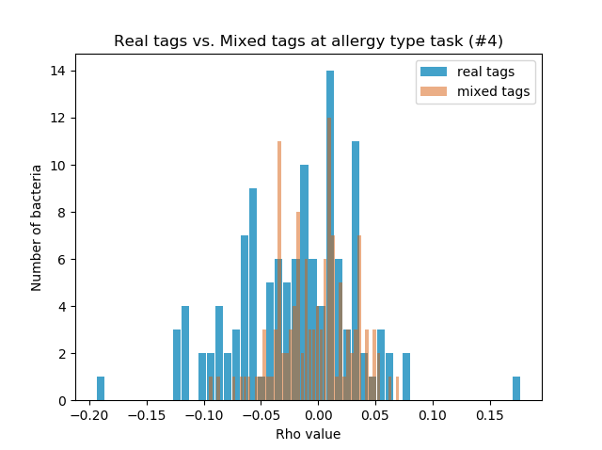 Significant bacteria -

|  |  |
| --- | --- |
| -0.12018 | k__Bacteria; p__Firmicutes; c__Clostridia; o__Clostridiales; f__Veillonellaceae |
| 0.17747 | k__Bacteria; p__Proteobacteria; c__Alphaproteobacteria; o__Rhizobiales; f__Bradyrhizobiaceae |
| -0.19425 | k__Bacteria; p__Proteobacteria; c__Betaproteobacteria; o__Burkholderiales; f__Oxalobacteraceae |
| -0.12046 | k__Bacteria; p__Synergistetes; c__Synergistia; o__Synergistales; f__Synergistaceae |
| -0.12038 | k__Bacteria; p__Tenericutes; c__Mollicutes; o__RF39; f__ |

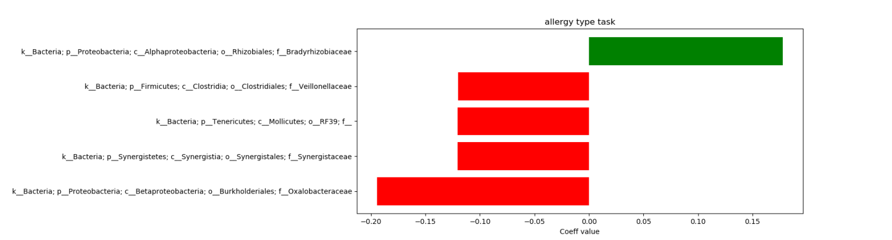

Can't calculate AUC for multi-class, there for accuracy score:

|  |  |  |
| --- | --- | --- |
|  | train accuracy | test accuracy |
| 0 | 0.94375 | 0.48125 |
| 1 | 0.926563 | 0.51875 |
| 2 | 0.921875 | 0.5125 |
| 3 | 0.917188 | 0.55625 |
| 4 | 0.928125 | 0.53125 |
| 5 | 0.926563 | 0.575 |
| 6 | 0.926563 | 0.50625 |
| 7 | 0.942188 | 0.5375 |
| 8 | 0.921875 | 0.525 |
| 9 | 0.929688 | 0.55625 |
| average | 0.928438 | 0.53 |

Confusion matrix

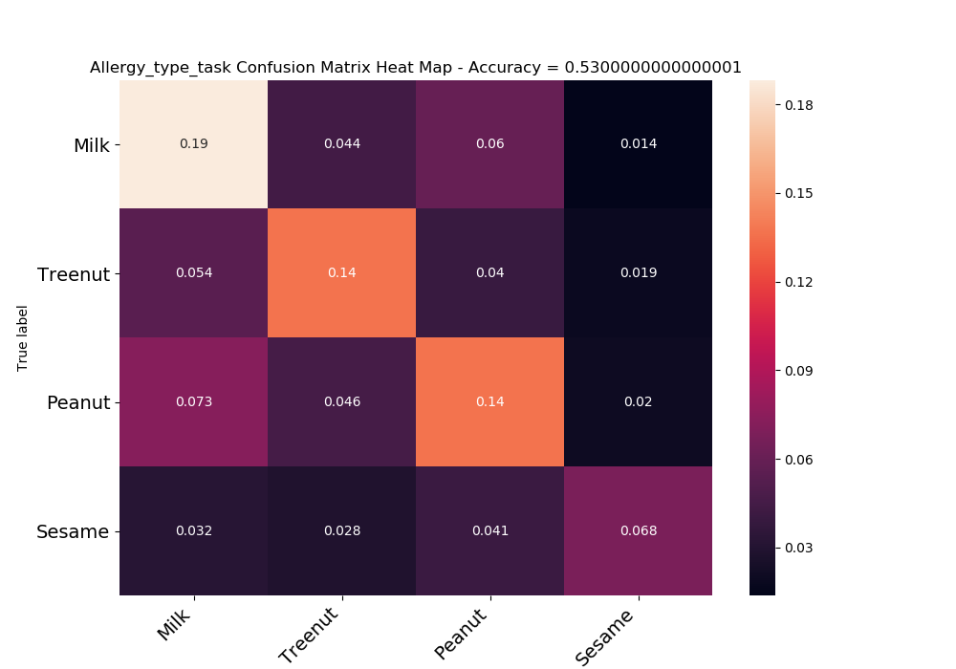

|  |  |  |  |  |
| --- | --- | --- | --- | --- |
|  | Milk | Treenut | Peanut | Sesame |
| Milk | 0.188125 | 0.044375 | 0.06 | 0.01375 |
| Treenut | 0.054375 | 0.136875 | 0.04 | 0.01875 |
| Peanut | 0.0725 | 0.045625 | 0.136875 | 0.02 |
| Sesame | 0.031875 | 0.028125 | 0.040625 | 0.068125 |
| acc | 0.53 |  |  |  |

Roc-

This is a commonly used graph that summarizes the performance of a classifier across all possible thresholds. It is generated by plotting the True Positive Rate (y-axis) against the False Positive Rate (x-axis) as you vary the threshold for assigning observations to a given class.

confusion matrix

is a performance measurement for machine learning classification problem where output can be two or more classes. It is a table with 4 different combinations of predicted and actual values.

It is extremely useful for measuring Recall, Precision, Specificity, Accuracy and most importantly AUC-ROC Curve.

Let's understand TP, FP, FN, TN in terms of pregnancy analogy.